BAGINTON PARISH COUNCIL
59, Meadow Road, Wolston, CV8 3HL
Tel: 07957589626
Email: bagintonpc@gmail.com

Minutes of the parish council meeting of Baginton Parish Council
Held on 23rd October 2025 at 7.30pm at Baginton Village Hall

Cllrs present: Cllr Bush, Cllr Horsfall and Cllr Newman, Cllr Colville Cllr Goodwin Cllr Parkes, Cllr Biggerstaff Cllr Taylor,
In attendance, County Cllr Edwards, District Cllr Redford and Tracie Ball, Clerk and 9 members of the public
The Chairman opened the meeting at 7:30pm, welcoming all those present
- Apologies: to receive apologies and approve reasons for absence.
Cllr Meakin
- Declarations of interest
  - To declare any personal interests or prejudicial interests in items on the Agenda and their nature.
NONE
  - To receive, consider and approve any requests for dispensation relating to Agenda items.
NONE
- Minutes of previous meeting: To approve the minutes as circulated.
  - 25th September 2025
RESOLVED: that the minutes of the previous meeting held on 25th September 2025 - having been read and circulated be signed as a correct record. Proposed Cllr Colville Second Cllr Bush unanimous
- Information items: to consider and discuss items for information and comment if appropriate:
  - County Councillor report
Cllr Edwards reported that WCC has proposed single unitary please see APPENDIX 1 for Press release.
District Councillors report
Warwick District Council has obtained the Warm Homes Local Grant funding from the Department of Energy, Security & Net Zero – for more information - Phone: 0800 988 2881, Email: advice@actonenergy.org.uk, Website: www.actonenergy.org.uk
  - Local Government Reorganisation in Warwickshire update – APPENDIX 1
- BagFest: The committee will present outline ideas to the Parish Council
Geoff Bull, Chair of Baginton Festival Committee, gave a short presentation to inform Councillors about Bagfest Live July 11th 2026, a copy of the presentation APPENDIX 2
- Public participation:
A resident asked about leaves on the pavement who is responsible. Asked for photos, and Clerk will report.
Shrubbery Frances Road – still dangerous. Cllr Edwards has reported to WCC
Community Café do Christmas do – 3 course and small gift. – grants available
A resident has asked if the Parish Council can do anything about an unsightly skip which seems to be constantly in a front garden. The Clerk to investigate.
CLOSED 20.01
- South of Coventry (SoC) Development Update
Cllr Redford – NOKSOC – quarterly – planning officer working on local plan – meeting still needs to be planned
- Police matters Update
Minutes have been circulated to councillors
- Baginton Events Committee matters to note
Penguin Lessons – well attended
24th October – Mr Burton
21st November - The Amateur
21st December - Holly Walk Christmas carols 7pm
- Coventry Airport Update - meeting 16/10/25
Cllr Horsfall and County Cllr Edwards attended, nothing tangible to report back – possibility two Giga factories
Rigby representatives – reserved matters – is now for two – no detailed plan – what is the backup plan – none in place.

- Planning Items
  - SEGRO – Update – Appendix 3
Leaflet to be distributed. Sent to Walter direct – A5
  - UKBIC – Update
Planning update – consulting – they are already connected. – new guy in charge. Not guaranteeing won’t make a noise. They will do sound suppression retrospectively if it causes a problem. Exhaust gas is increasing. Waiting till installed. Email to District Cllr Redford – Batch production is happening, 500 is maximum allowed at present.
Need to consider BPC reaction. Not what we expected – already in place, noise needs to be sorted not resolved. Retrospective sound dampening not good enough. Need to report if you can hear anything whilst in your property.
  - WM IZone – Update Appendix 4
WCC have raised concern and reservations about the sole use for GIGA factory.
  - Planning decisions received since the last meeting
None
  - To note applications awaiting WDC decision.
    - DOC/23/0018 – Discharge of Conditions 3, 5, 7, 8, 14, 16, 19, 20, 21, 24 and 25 relating to W/20/0808 (Building of 56 affordable houses off Church Road on land NORTH of Rosswood Farm). Special notes on Condition 8 (Surface water drainage). OBJECTION response issued 18th January 2024.
Teams meeting with Rob Young – decision circulated
    - DOC/24/0010 – Discharge of condition 23 (the need for a construction traffic management plan) - Gateway South development on Bubbenhall Road. NEUTRAL response issued 30th April 2024.
    - W/25/0125 - Landscaping, car parking, earthworks, strategic drainage features, a primary substation, demolition of existing structures, plus formation of the six approved access points and the main spine road within the site. Coventry Airport, Rowley Road. OBJECTION response issued 17th March.
    - W/25/0293 – Reserved matters pursuant to Condition 1 (landscaping, planting, parking, lighting, house design etc.) relating to W/22/1038 – Land AT Rosswood Farm. OBJECTION reported 7th April.
    - W/25/0265 – Reserved matters (building size, appearance, floor plan, site layout, landscaping, planting etc, plus power, noise and lighting) pursuant to a Gigafactory on Coventry Airport, Rowley Road. OBJECTION reported 8th April
    - W/25/0502 – Reserve Matters relating to the provision of a substation (landscaping, earthworks, access, appearance etc.) – Coventry Airport, Rowley Road. OBJECTION reported 3rd May.
    - DOC/25/0023 – Discharge of Conditions 5, 7 and 8 (Construction Management, Environmental and Landscape Plans) AT Rosswood Farm, Church Road. OBJECTION reported 3rd May.
    - Planning Application W/25/0816—Land West of Firefly Road, Baginton Full application for the erection of commercial buildings, with associated infrastructure, landscaping, drainage, ground modelling and access - OBJECTION – leaflet circulate
    - W/25/1215 Gateway South, Land to the South and West of Coventry Airport and Middlemarch Industrial Estate, Coventry, Outline application (all matters reserved) for the erection of commercial buildings, with associated infrastructure, landscaping, drainage, ground modelling and access. Standard Consultation Expiry Date 3 October 2025 –
meeting with SEGRO last week - SEGRO are going to issue a document to say no changes – neutral RH and wb
    - W/25/1228/TP The Bungalow, Hall Drive, Baginton, Coventry, CV8 3AF. Pruning and felling of various trees Exp 3 October 2025 – neutral – subject to NHC
    - W/25/0293 Reserved matter pursuant to Condition 1 of Outline Planning Permission W/22/1038 at Rosswood Farm Bungalow, Coventry Road, Baginton,
Amended plans and additional information. Observations and comments on the amendments, by 30 September 2025. Extension requested
  - New planning applications or matters received since the last meeting
    - W/25/1226 Two-storey front and side extension 30 Mill Hill, Baginton, Expiry Date 13 November 2025
RESOLVED: SUPPORT Proposed Cllr Biggerstaff Second Cllr Horsfall unanimous
    - W/25/1228 The Bungalow, Hall Drive, Baginton, Coventry, CV8 3A Pruning and felling various trees
RESOLVED: NEUTRAL Proposed Cllr Horsfall Second Cllr Bush unanimous
    - W/25/1310 Walkers Snack Foods Ltd Unit W, Siskin Parkway West, Middlemarch Business Park, Installation of new single-storey modular office building on existing hardstanding
RESOLVED: NEUTRAL Proposed Cllr Colville Second Cllr Newman unanimous
    - W/25/1316 Lucy Price House, Church Road, Baginton 1 x Cherry – Remove
RESOLVED: NEUTRAL Proposed Cllr Parkes Second Cllr Horsfall unanimous
    - W/25/1463/AG 13 The Smallholdings, Stoneleigh Road, Baginton Prior approval notification under Schedule 2, Part 6, Class A for the erection of 2no. agricultural buildings for the storage of machinery, hay and associated equipment, and an access track
RESOLVED: Defer to next meeting
- Highways Matters
  - Road drain cleaning project update to include HCAF grant application
Clerk has emailed WCC to seek advice on recommended suppliers
- Open Spaces Committee matters to note – meeting 15/10 Notes Appendix 5 –
RESOLVED: NEUTRAL Proposed Cllr Parkes Second Cllr Horsfall unanimous
propose £300 for maintenance – no dogs – CB
VE day memorial tree planting – 10 am 8/11 – Tudor environmental have offered up to 20 stakes and ties.
- General Open Spaces Matters to consider/decide matters relating to each as required.
  - Lucy Price Playing Field Maintenance Update
All reports received and no major issues highlighted.
  - Update on software platforms that the record safety of play equipment.
Not chased as I pad (not Tablet) is required
- UK GDRP Compliance – To consider quotes received to provide council-owned domain for email and to operate an accessible website.
Clerk is waiting for quotes, Cllrs provided with detailed information
ACTION Clerk to request quote from joecrawley@outlook.com,
- Finance –
  - To approve accounts for payment.
RESOLVED: Payment schedule confirmed Proposed Cllr Colville Second Cllr Bush unanimous
  - To confirm payment of Clerk's and Councillors Expenses. –
none
  - To note finance update including bank reconciliation. –
Noted
  - To note payments received.
Noted
  - Any further financial matters to consider
    - Costs for repairs to The Smithy
RESOLVED: Defer to next meeting Proposed Cllr Parkes Second Cllr Horsfall unanimous
    - ADDITIONAL - To note the Joint Council for Local Government Services (NJC) has come to an agreement on the 25/26 pay award, applicable from 1st April 2025 to 31st March 2026
Noted
- Matters relating to the parish from Councillors and Clerk – to consider/decide matters relating to each as required.
  - Any other matters arising.
Edinburgh villas – skip – rats
Growth on foot path – Rowley and Coventry
CHRISTMAS TREE -
- Future Agenda Items – Councillors are asked to use this opportunity to raise items for future agendas. Councillors are respectfully reminded that this is not an opportunity for debate or decision-making.
None
- Parish Council Communications (information for sharing) - To receive suggestions for items for the Village website, Parish Council Facebook Page, and Baginton E-news.
On going
- Date of Next Meetings – To discuss and consider the dates of the next parish council meetings as there is currently a clash with Cubbington Parish Council, and to agree the date for the next Parish Meeting at the Village Hall
If an interim meeting is required, an agenda will be sent to Councillors and be put on the website and in the Parish noticeboard three clear days before the meeting is held.
- Confidential matters: to consider the exclusion of the public and press in the public interest for discussions and decisions in relation to either Personnel matters or Legal matters.
Exclusion of Press and Public
In accordance with Paragraph 1 (2) of The Public Bodies (Admission to Meetings) Act 1960, the Parish Council is invited to Resolve that the press and public be excluded from the meeting during consideration of the following agenda items owing to the confidential nature of the business to be transacted and the public interest would not be served in disclosing that information.
None

- Upcoming meetings
Date | Meeting | Time | Location | Comments
27th November | Baginton Parish Council | 7.30 pm | Baginton Village Hall
TBC | Police ASB |  | Virtual
22 December | WRE Police and Parish Liaison | 7.00 pm | Leek Wootton Police HQ
December | SEGRO Liaison | 4.15 pm | Management Suite
TBC | WDC: IZone, Gigafactory etc | 2.00 pm | Baginton Village Hall
14/01/26 | Open spaces | 7.30 pm | Baginton Village Hall

Meeting Closed 21:05

Signed …………………………………….

Date ……………………………………….

APPENDIX 1
Warwickshire County Council
14th October 2023 Extraordinary Meeting of the County Council the following decision was made:-
Decision:

- This Council recommends that in making its decision on the final submission to the Secretary of State for Housing, Communities and Local Government, the Cabinet takes into account:
That the Council recognises the importance of Town and Parish Councils, supports the establishment of such councils where they do not currently exist (e.g, Nuneaton, Rugby, Bedworth, Bulkington), and endorses the role of Town and Parish Councils as a necessary means of preserving local identity along with the devolution of roles and powers to such councils where there is an appetite to do so.
- This Council recommends that in making its decision on the final submission to the Secretary of State for Housing, Communities and Local Government, the Cabinet takes into account:
That the Council accepts that full constituent membership of the West Midlands Combined Authority would be the best arrangement for any new unitary authority or authorities in Warwickshire to meet the Government’s requirement of full devolution.

- This Council recommends that in making its decision on the final submission to the Secretary of State for Housing, Communities and Local Government, the Cabinet takes into account:
That the Council supports the proposal of a single unitary council for Warwickshire as the optimum model of local governance.

Background documents and the webcast of the meeting can be found at Information and Documents – Warwickshire County Council

Warwick District Council
Published: Friday, 10th October 2025
A public survey of Warwickshire residents has found that a majority (73%) would favour two unitary authorities rather than one after the reorganisation of local government for the County in 2028.
Between 7 August and 14 September 2025, over 2,300 people provided feedback that will help to inform how councils are structured and residents access services from April 2028, when the Government’s requirement for Local Government Reorganisation (LGR) takes effect.
Under Government plans for Local Government Reorganisation, Warwick District Council Stratford-on-Avon District Council, Nuneaton and Bedworth Borough Council, Rugby Borough Council, North Warwickshire Borough Council and Warwickshire County Council will be abolished on 1 April 2028. They will be replaced by either one single unitary council for Warwickshire or two unitary councils – one for the North and one for the South – with each authority responsible for all services for its part of the county.
The Leaders of Warwick District Council, Stratford-on-Avon District Council, Nuneaton & Bedworth Borough Council and North Warwickshire Borough Council said: “We would like to thank everyone across Warwickshire who took the time to comment as part of the recent Local Government Reorganisation engagement exercise. "It's the biggest shake-up of local government in a generation and therefore it is important that we involve all our residents in the redesign of how services will be provided as part of a new arrangement of councils in Warwickshire.”
A final detailed report will be published towards the end of October, which will also provide feedback from focus groups and interviews with key stakeholders.
Survey feedback, analysis and other relevant information will be taken into account before the councils formally submit their final reorganisation proposals to the Government by 28 November 2025. Following this, the Government will consult on the proposed plans before making a final decision in 2026. If approved, the new unitary authorities are expected to be in place by 2028.

APPENDIX 2
This is not the exact copy of the presentation left with Councillors
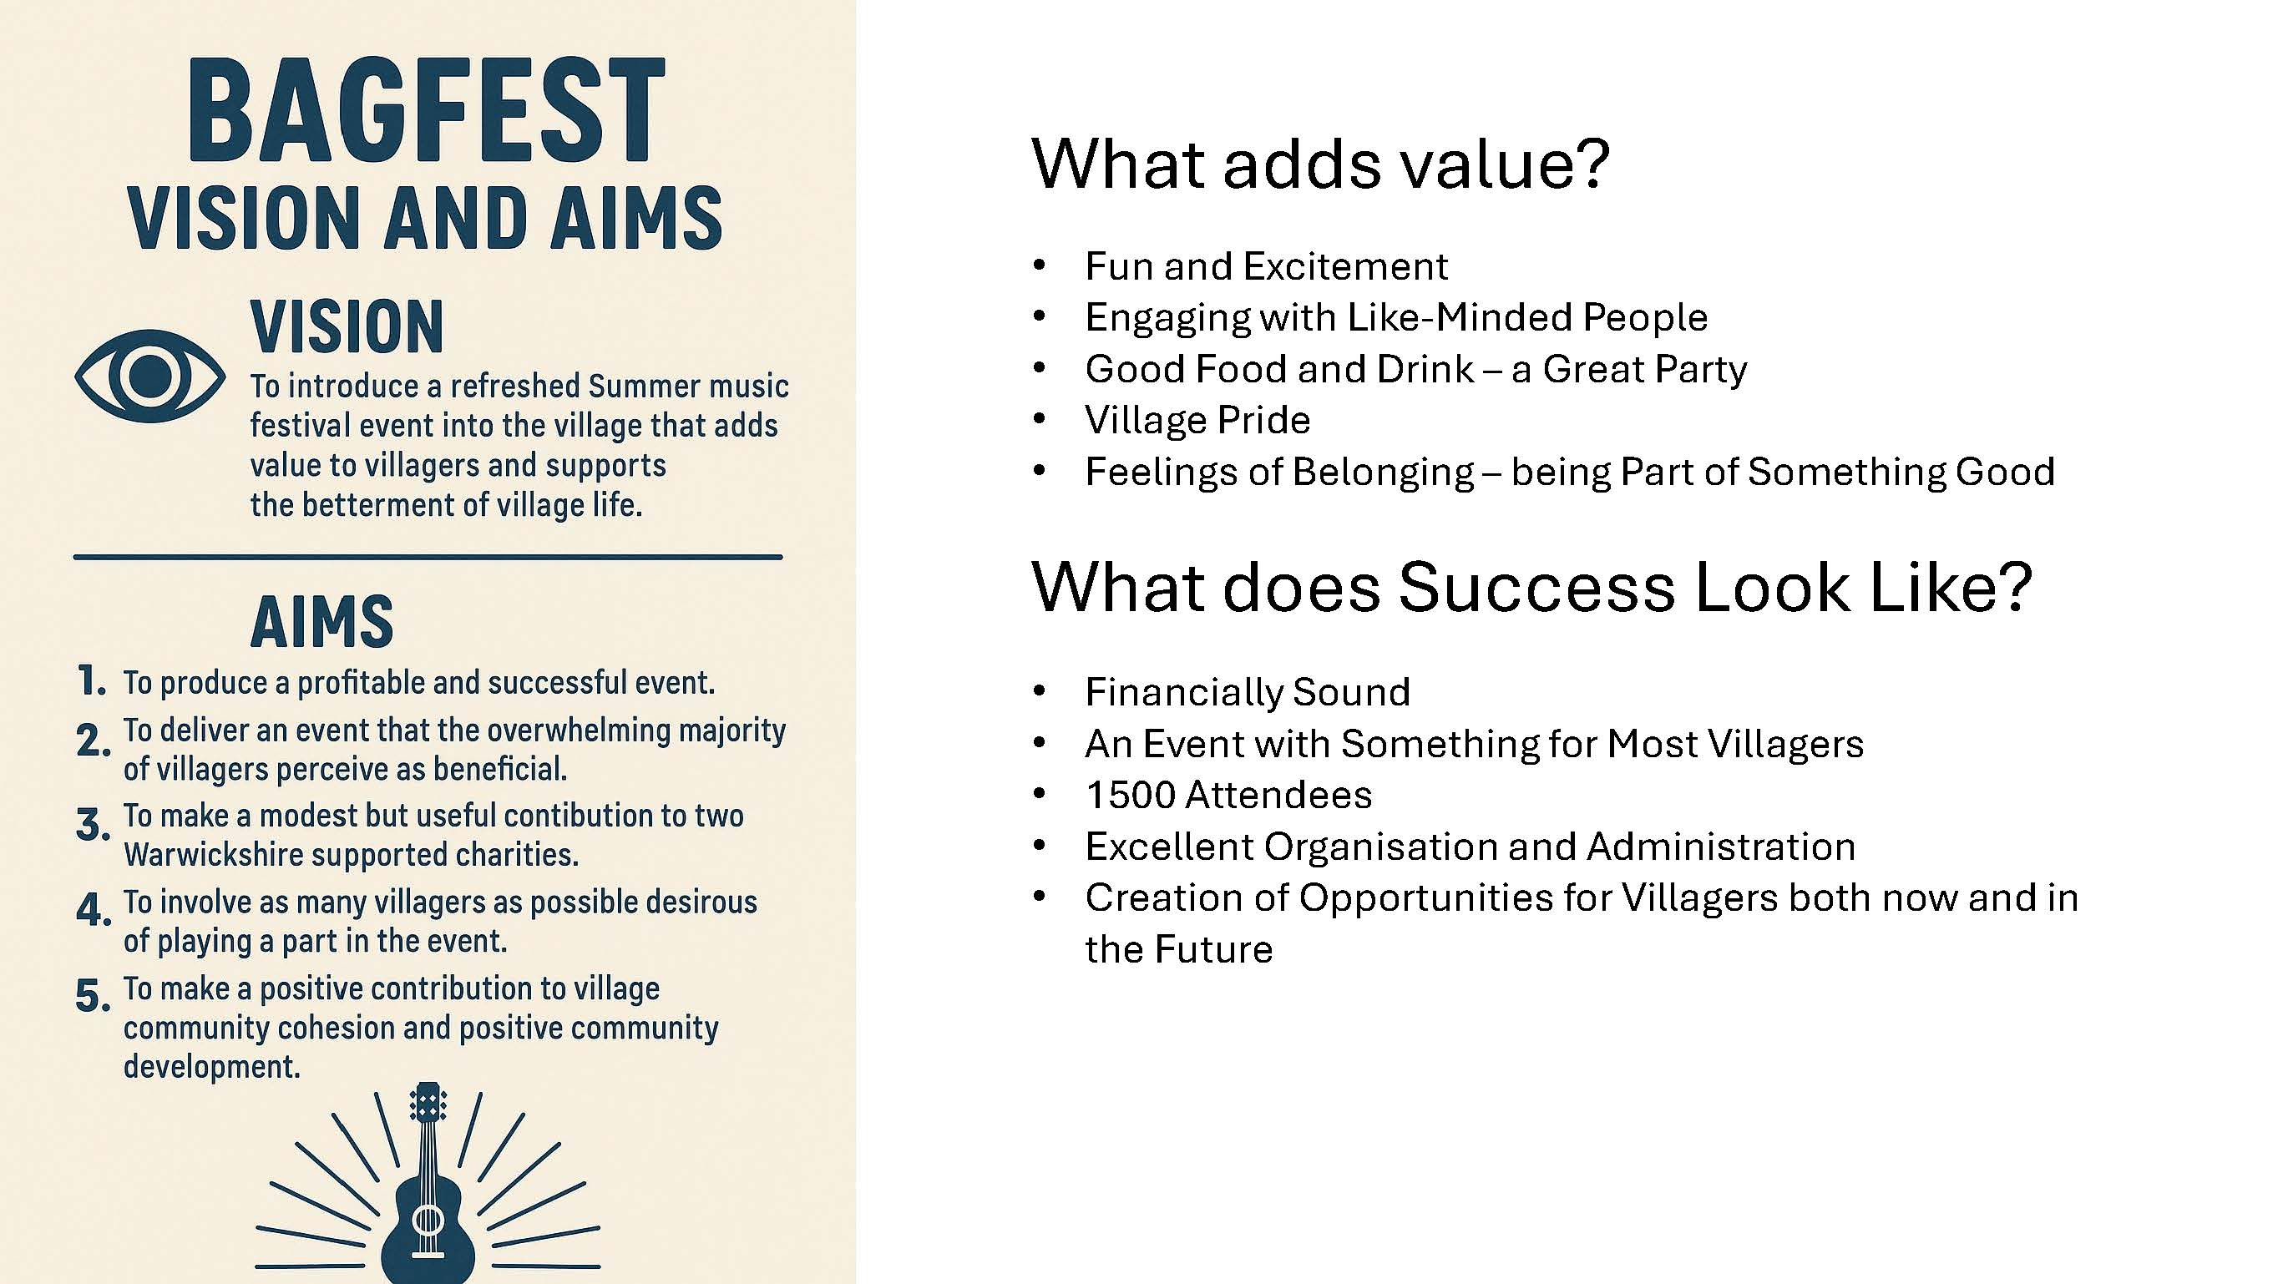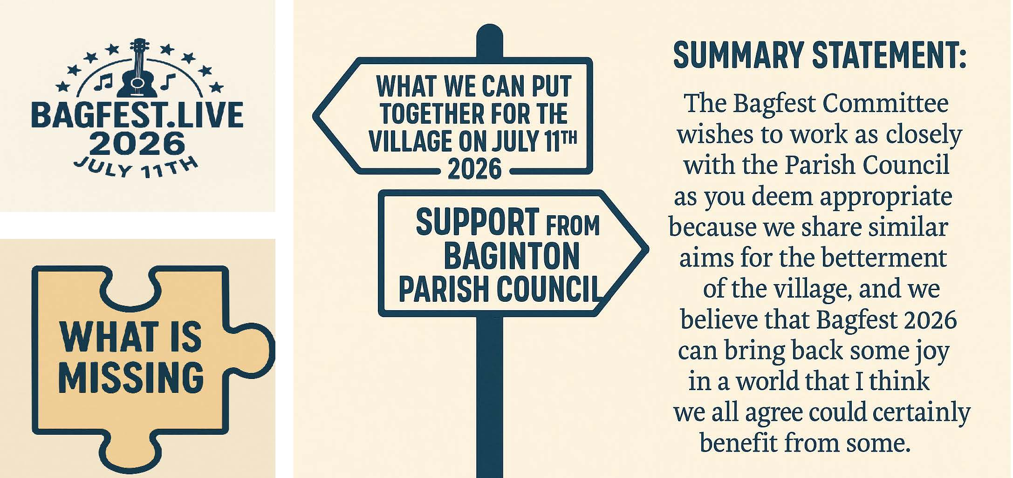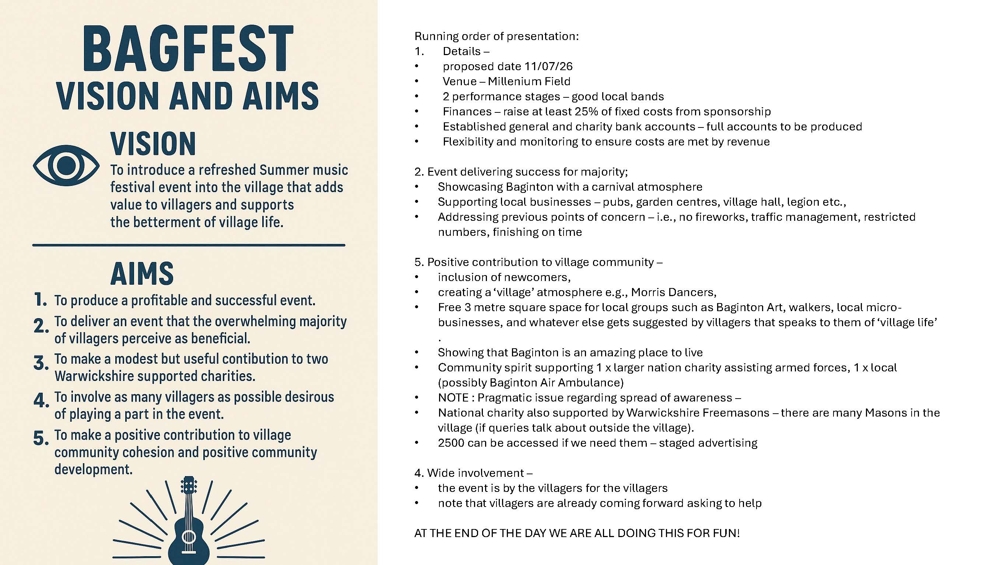
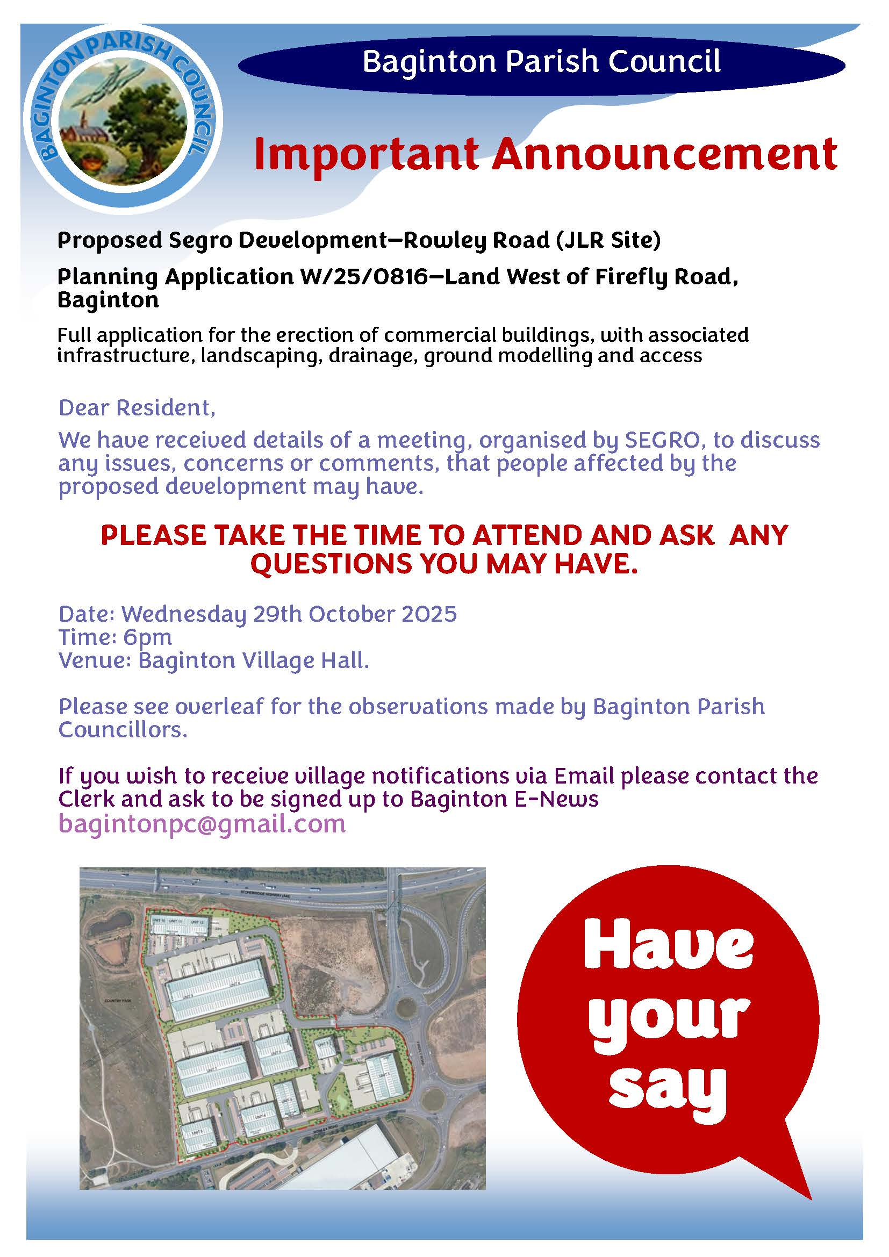
APPENDIX 3
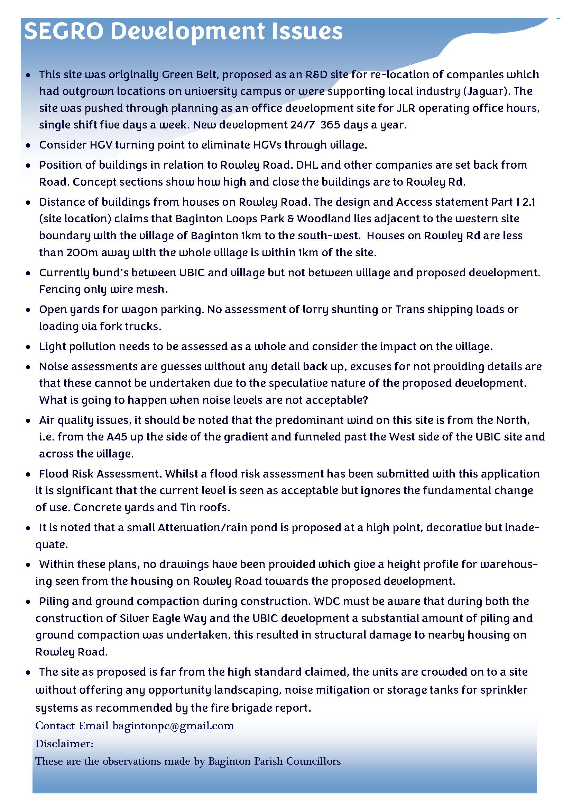
Notes from The Investment Zone meeting – 24 September 2025 APPENDIX 5
Present. Chris Elliott WDC Chief Executive, Phil Clark WDC Head of Development, Gary Fisher WDC Planning, Adam Walker, WDC planning officer, Cllr Pam Redford District Councillor, Cubbington and Leek Wootton ward, Cllr Walter Bush Chairman of Baginton PC, Cllr Roger Horsfall, Baginton PC, Cllr Jim Roberts, Chairman Bubbenhall PC, Cllr John Astle, Stoneleigh PC.
WDC Chief Executive, Chris Elliott opened the meeting with an update of the last IZone meeting September 2025:
The Investment Zone Board met this week, with all recommendations from the agenda papers agreed
The Board endorsed the Strategic Delivery Plan for 2025/26, which sets out priorities for the coming year, including long-term development work on business rates reinvestment and further integration of the Investment Zone into regional economic plans.
The Board approved the revised list of Warwick District Council Local Growth Initiatives.
The Board approved the allocation of £2 million of Investment Zone funding to Midlands Mindforge Ltd, supporting equity investment into IP-rich, early-stage businesses across the Midlands, with a focus on advanced manufacturing, clean tech, and health-tech sectors.
Full Business Case Completion
The £21m Full Business Case (FBC) grant aid agreement has now been engrossed by both WMCA and Coventry City Council, marking its completion.
This enables the CCC/Coventry Airport Limited joint venture to proceed with works to deliver a 30MVA power supply to the Greenpower Park site by 2027, increasing to 50MVA by 2029.
Mass Transit Study Progress
Work continues on the Coventry & Warwick Investment Zone Mass Transit Study, commissioned by TfWM and delivered by Mott MacDonald and ITP.
The third workshop has now taken place, discussing a longlist of potential routes from Coventry City Centre to Investment Zone sites.
The final study outcomes are expected by the end of the year.
Chinese Energy Delegation Visit
This week, a delegation of Chinese energy storage companies—including CATL, EVE Energy, and Sungrow—visited the region.
The visit included a full day at UKBIC, with presentations from the Faraday Institute and APC, and a site tour of CWIZ.
CWIZ featured prominently in the agenda, and follow-ups are now underway, with one direct enquiry already received. Follow ups with CATL, EVE Energy and UiTHIUM have already started building on the strong contacts and investment opportunities from the recent China Trade Visit.
Power supply
Cllr Redford asked if a power station would be built, and explained that she had in the past asked about surplus energy being produced from the solar panels installed on SEGRO and IZone buildings and fed to the residents of Baginton, but because of the inability of the Grid to use this energy it would not be possible. The question of power to the development in general was discussed and Cllr Bush reported that the National Grid was not yet able to receive any surplus energy generated from the buildings already built in the Segro park area and was unlikely to be in a position to do so in the near future. Some further discussion followed. Mr Elliott was of the opinion that a conversation needed take place with the National Grid (HQ based in Leamington) WDC would undertake to ask National Grid how this surplus could be used as a benefit to local residents.
Grant funding
Cllr Redford ask Cllr Bush if Baginton had moved forward with applying for any of the grant sources that had been passed on to the PC. Cllr Bush responded by saying that they had all been very busy of late and would ask the new parish clerk to follow up on this.
Traffic issues
Traffic issues were raised by both Cllr Redford and Cllr Bush relating to the Toll Bar Island, this roundabout is not in any way the best designed traffic island and concern was about the increased traffic which would come from not only a Gigafactory but also from the IZone. The general view was that the traffic issues needed to be re-visited and its impact on Baginton village re-assessed . The new application for the JLR site (Firefly Rd) was discussed and Cllr Bush explained his view of the problem, they are - HGVs through the village, noise, 24hr working close to residential properties and the access and exit points. Adam Walker explained that WDC were looking at the access points. There followed general discussions on the present traffic issues and the impact of further development in the area and particularly on Baginton village.
Cllr Robert's raise the question of using part of the airport to build/use as a vertical take-off aircraft production and airport - details to be forwarded to Mr Elliott.
Cllr Redford asked if there was any information on an "end user" coming forward for the Gigafactory site, WDC responded that there was none at this time and acknowledged that raised uncertainty.
Cllr Redford thanked all those in attendance for their time and closed the meeting at 14.55pm.
APPENDIX 5
Baginton PC – Open Spaces, Meeting 7, Notes. 15th October 2025, Committee Room, Village Hall.
Attending; Rheba Horsfall, Roger Horsfall, Walter Bush, Robert Taylor, Andrew Robinson [Chair,] Ralph Johnson, Andrew Parkes, Sarah Cusworth.
Apologies;. Anne Taylor, Tristan Patrick, Michelle Gilkes
COMMUNICATIONS;
AR to check notices have now been put on notice boards.
WILDLIFE RECORDING;
Not discussed.
ROMAN WAY;
AP. Keeping a watching brief. No issues.
LPPF
Hedge Gaps. RJ contacted Woodland Trust. Hedge plants available in spring. ReH has some in store. To be planted when soil is wet and plants are bare root. November/December.
Weeds. Job done.
Paint. No progress. RT to ask Jarrod if he could do it in spring 2026.
Mulch failing near inclusive swings. RT seeking a solution.
Concrete path down to ‘train’ under discussion. RT WB
‘No Dogs’ signs arriving 16/10. RT to arrange fitting to bins
MILLENNIUM FIELD;
VE day tree planting, November 8th at 10am. agreed, weather permitting. RJ to consider layout and positions with RhH and RoH.
RJ has been offered a tree each from Smiths and Russells.
BRING – Spades, plastic tree protectors, stakes and hammer, ties [old inner tubes. Tights or other soft tie methods]
Curtilage needs rough cut.
Winter pruning in January
OAK GLADE /SPINNEY
December 6th at 10am. Cutting brush and general tidying. People are building dens with debris from building site etc.
Lovells have placed rat boxes in the spinney without asking BPC.
Swallows. WB spoke to Chris Elliot, WDC who accepted they had been remiss. They have offered funding for alternative accommodation for swallows but swallows need particular nesting conditions eg inside barns etc.
Benches; WB has quote of £370 + £90 delivery for recycled plastic planks to repair the rotting benches. Will put a proposal to BPC.
AOB.
Animal shelters; Sarah brought one donated by Jo Wagstaff. Tim Jardine has said he will produce some ‘soon.’ So keep building or begging. To be installed over the winter.
RDT expects to move to Plymouth early next year. The LPPF will need a new lead.
SEGRO;
Becoming increasingly adversarial as SEGRO are determined to turn the Rowley Road site into an intensive warehouse site with 24/7 activity. Public meeting to be held at Village Hall on 29/10/25 at 6pm. Baginton needs as many residents to turn up as possible and object to this totally unacceptable development which will blight our lives during construction and operation.
Next meeting; January 14th 2026 at 7.30PM, Village Hall Committee Room. Please enter via side door.

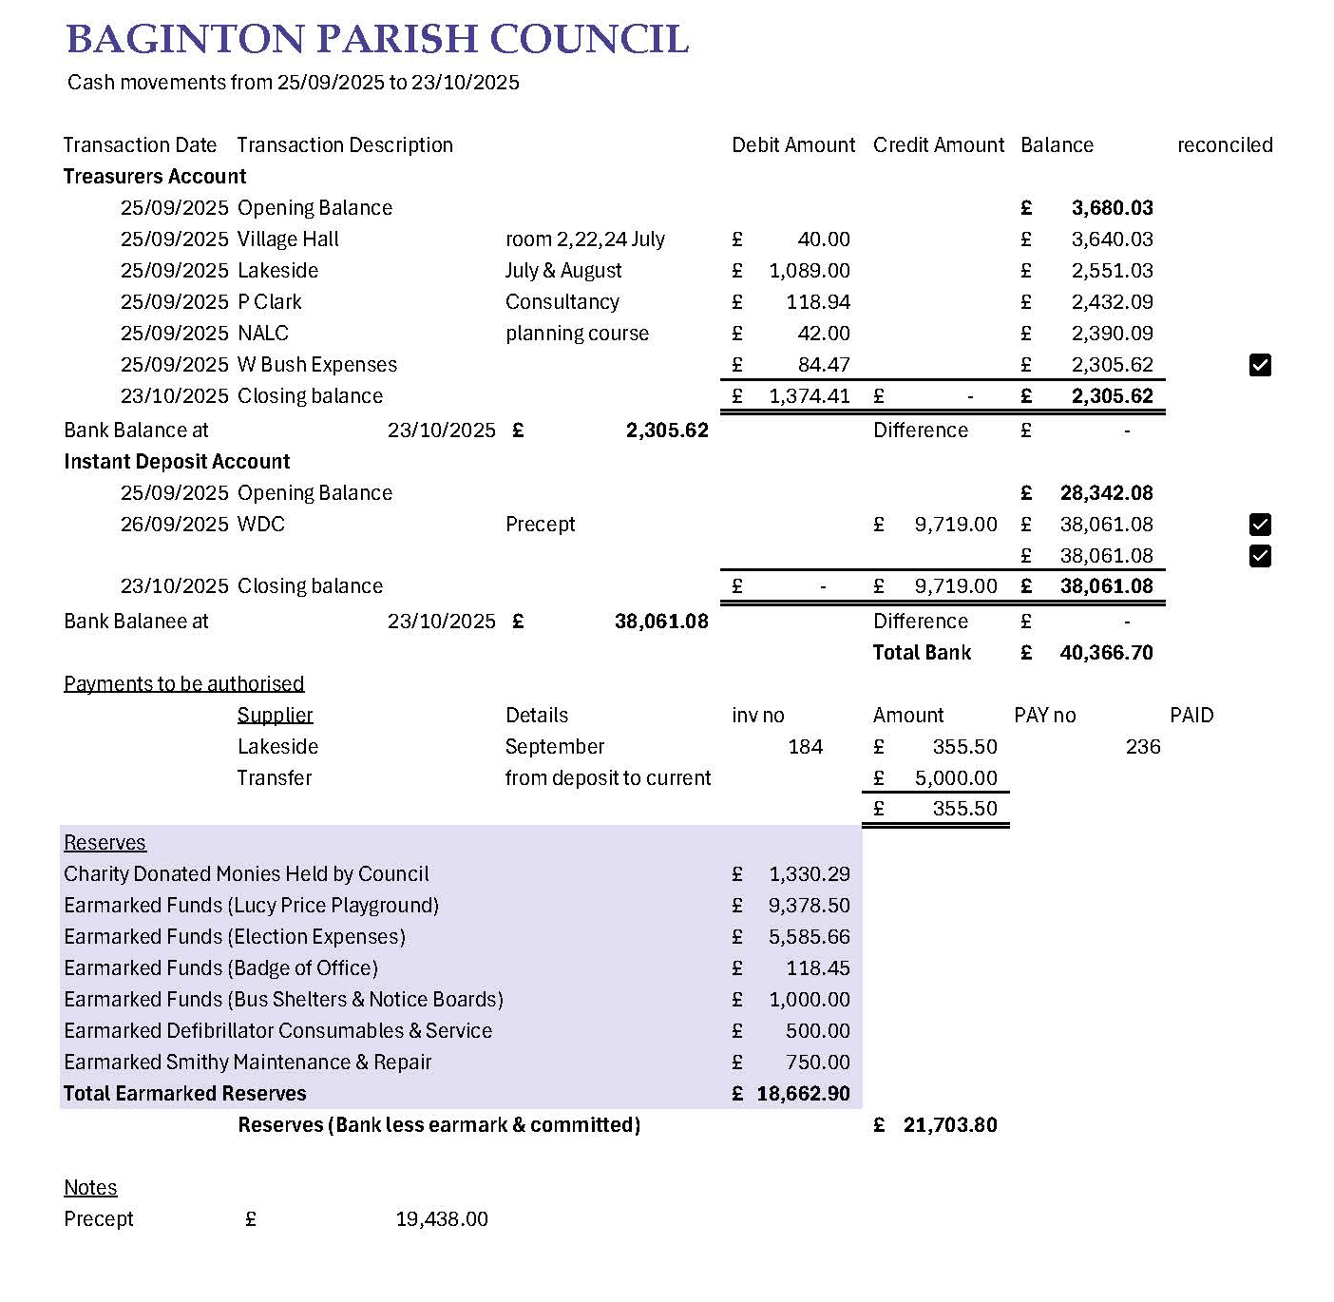
APPENDIX 6

