BAGINTON PARISH COUNCIL
59, Meadow Road, Wolston, CV8 3HL
Tel: 07957589626
Email: bagintonpc@gmail.com – clerk@bagintonparish.gov.uk
ANNUAL PARISH ASSEMBLY – 9th APRIL 2025
To the Members of Baginton Parish Council, Representatives of Warwickshire County and District Councils, Representatives of the Police and Press, Residents, representatives of the Church, Charities, Clubs & Community Organisations.
You are reminded that the Annual Parish Assembly for Baginton is to be held at Baginton Village Hall on Thursday 9th April 2026 from 7:30 pm.
The AGENDA will be as follows but is subject to change at the Chairman’s discretion.
- To note the Minutes of the last Annual Assembly on 10th April 2025.
ANY QUESTIONS
- To Receive the Parish Council Report, presented by the Chairman.
ANY QUESTION
- Any Warwickshire County Council Matters to Report
ANY QUESTIONS
- Any Warwick District Council Matters to Report
ANY QUESTIONS
- Any Police Matters to Report
ANY QUESTIONS
- Reports by Parochial Charity Representatives
- Lucy Price Relief in Need Charity
- Baginton Village Hall Management Committee
- Lucy Price Sunday School Fund
- Matters arising from the floor.
- Closure
Yours faithfully
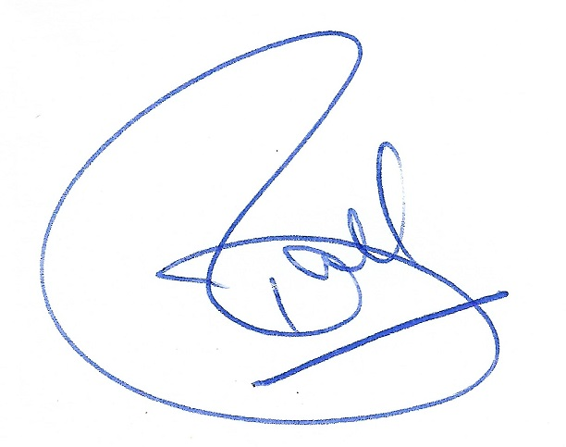
Tracie Ball
Clerk and RFO
31st March 2026
- Upcoming meetings
Date | Meeting | Time | Location | Comments
09/04/26 | Annual Parish Assembly | 7.30 pm | Baginton Village Hall
23/04/26 | Baginton Parish Council | 7.30 pm | Baginton Village Hall
18/05/26 | Police ASB | 10.00 am | Virtual
April 26 | WRE Police and Parish Liaison | 7.00 pm | Leek Wootton Police HQ
June 26 | SEGRO Liaison | 4.15 pm | Management Suite
May 26 | WDC: IZone, Gigafactory etc | 3.00 pm | Virtual | Teams
June 26 | NoKSoC | 4.00 pm | Virtual | Teams
April 26 | Open spaces | 7.30 pm | Baginton Village Hall
April 26 | Baginton Events | 7.30 pm | Baginton Village Hall
April 26 | Firefly Working Group

