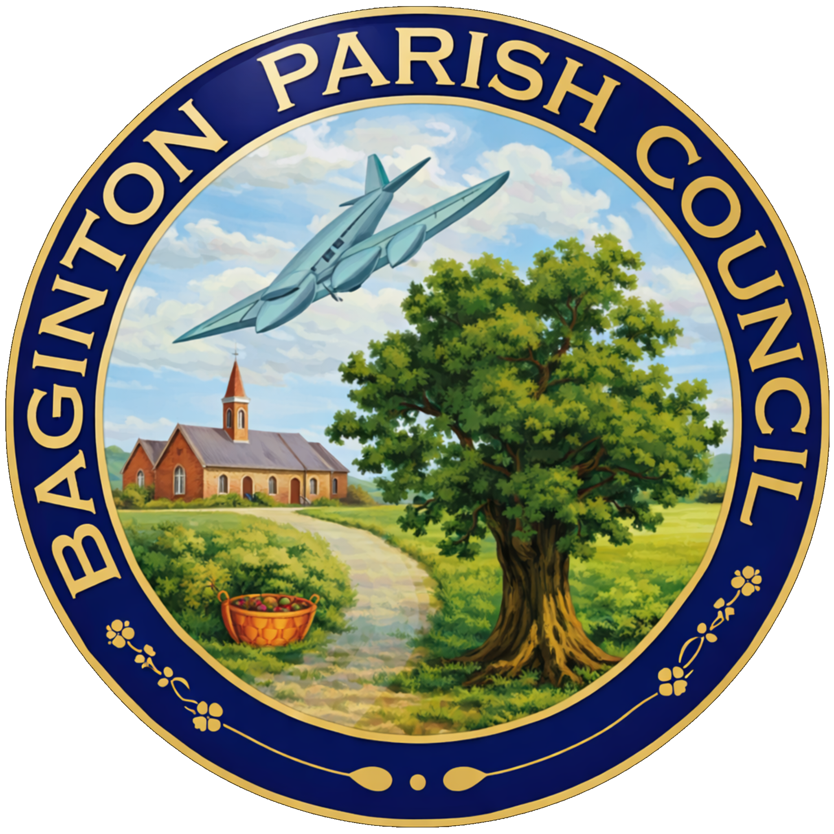
BAGINTON PARISH COUNCIL
59, Meadow Road, Wolston, CV8 3HL
Tel: 07957589626
Email: bagintonpc@gmail.com – clerk@bagintonparish.gov.uk

TO: All Councillors, Baginton Parish Council
Dear Councillor
You are hereby summoned to attend the Annual Parish Council meeting Baginton Parish Council at Baginton Village Hall on Thursday 28th May 2026 at 7.30pm. Please forward any apologies for absence to me or the Chair.
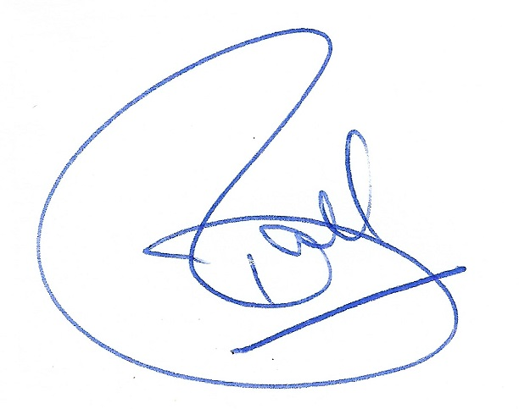
Tracie Ball
Clerk and RFO
20th May 2026

Members of the public and press are welcome to attend.
A G E N D A
- Receive declarations of acceptance from the two councillors co-opted on 6th May 2026.
- Election of Chair 2026-27
- To receive the Chair’s Declaration of Acceptance of Office
- Election of Vice-Chair 2026-27
- To receive the Vice Chair’s Declaration of Acceptance of Office
- Re-adoption of Standing Orders and Financial Regulations to be subject to review by August 2026
- Re-adoption of Policies and Procedures to be subject to review by August 2026
- Confirmation of Working Groups and membership
- Confirmation of Representation on outside bodies
- Apologies: to receive apologies and approve reasons for absence.
- Declarations of interest
  - To declare any personal interests or prejudicial interests in items on the Agenda and their nature.
  - To receive, consider and approve any requests for dispensation relating to Agenda items.
- Minutes of previous meeting: To approve the minutes as circulated.
  - 23rd April 2026 and
  - 6th May 2026
- Public participation: to adjourn to allow public participation for 15 minutes. Residents are invited to give their views and question the Parish Council on issues on this Agenda or raise issues for future consideration at the discretion of the Chair. If members of the public wish to raise issues which are not on the agenda, they should notify the Clerk, 5 working days prior to the meeting. Members of the public may not take part in the Parish Council meeting itself. Maximum 5 mins per issue.
- Police Matters Update –
- Baginton Events Committee
  - Update
- Coventry Airport Update
  - Giga Factory
- Information items: to consider and discuss items for information and comment if appropriate:
  - County Councillor report
  - District Councillors report
  - Update of SWLP
  - Local Government Reorganisation in Warwickshire update
- Planning Items
  - SEGRO PARK/Gateway South – Update
  - Firefly Road Development Working Group – Update
  - UKBIC – Update
  - WM IZone – Update
  - Planning decisions received since the last meeting
  - To note applications awaiting WDC decision. - 2
  - New planning applications or matters received since the last meeting
    - W/26/0431 2 Coventry Road, Baginton Single and two-storey side and rear extensions, front extension, addition of solar panels and detached outbuilding to rear
    - W/26/0487 28 Oak Close, Baginton Erection of single-story side extension
    - W/26/0490 Unit 1C, Plot 4020, Siskin Parkway East, Notification for Prior Approval under Schedule 2, Part 14, Class J of the General Permitted Development Order 2015 (as amended) for the installation of other solar PV equipment on a roof of a non-domestic premises
- Highways Matters
  - Proposed meeting for village consultation and make any decision as necessary
- Open Spaces Committee matters to note and update –
- General Open Spaces Matters to consider/decide matters relating to each as required.
  - Lucy Price Playing Field Maintenance Update
  - Noticeboards
  - Installation of spare Defibrillator update
- Finance
  - To approve accounts for payment.
  - To confirm payment of Clerk's and Councillors Expenses.
  - To note finance update including bank reconciliation.
  - To note payments received.
  - Any further financial matters to consider
    - Costs for repairs to The Smithy
  - Consider move to Unity Trust Bank and make any necessary decisions
  - Church grants report from previous years
- Matters relating to the parish from Councillors and Clerk – to consider/decide matters relating to each as required.
  - Any other matters arising.
- Future Agenda Items – Councillors are asked to use this opportunity to raise items for future agendas. Councillors are respectfully reminded that this is not an opportunity for debate or decision-making.
- Parish Council Communications (information for sharing) - To receive suggestions for items for the Village website, Parish Council Facebook Page, and Baginton E-news.
  - New Website and Email addresses – update
  - To consider setting up a GDPR Compliant Email newsletter facility for residents – update
- Date of Next Meetings – To confirm Thursday 25th June 2026 at 7.30pm for the for the next regular meeting of the Parish Council.
If an interim meeting is required, an agenda will be sent to Councillors and be put on the website and in the Parish noticeboard three clear days before the meeting is held.
- Confidential matters: to consider the exclusion of the public and press in the public interest for discussions and decisions in relation to either Personnel matters or Legal matters.
Exclusion of Press and Public
In accordance with Paragraph 1 (2) of The Public Bodies (Admission to Meetings) Act 1960, the Parish Council is invited to Resolve that the press and public be excluded from the meeting during consideration of the following agenda items owing to the confidential nature of the business to be transacted and the public interest would not be served in disclosing that information.
- Upcoming meetings
Date | Meeting | Time | Location | Comments
25/06/26 | Baginton Parish Council | 7.30 pm | Baginton Village Hall
18/05/26 | Police ASB | 10.00 am | Virtual
June 26 | WRE Police and Parish Liaison | 7.00 pm | Leek Wootton Police HQ
June 26 | SEGRO Liaison | 4.15 pm | Management Suite
June 26 | WDC: IZone, Gigafactory etc | 3.00 pm | Virtual | Teams
June 26 | NoKSoC | 4.00 pm | Virtual | Teams
 | Open spaces | 7.30 pm | Baginton Village Hall
 | Baginton Events | 7.30 pm
 | Firefly Working Group

