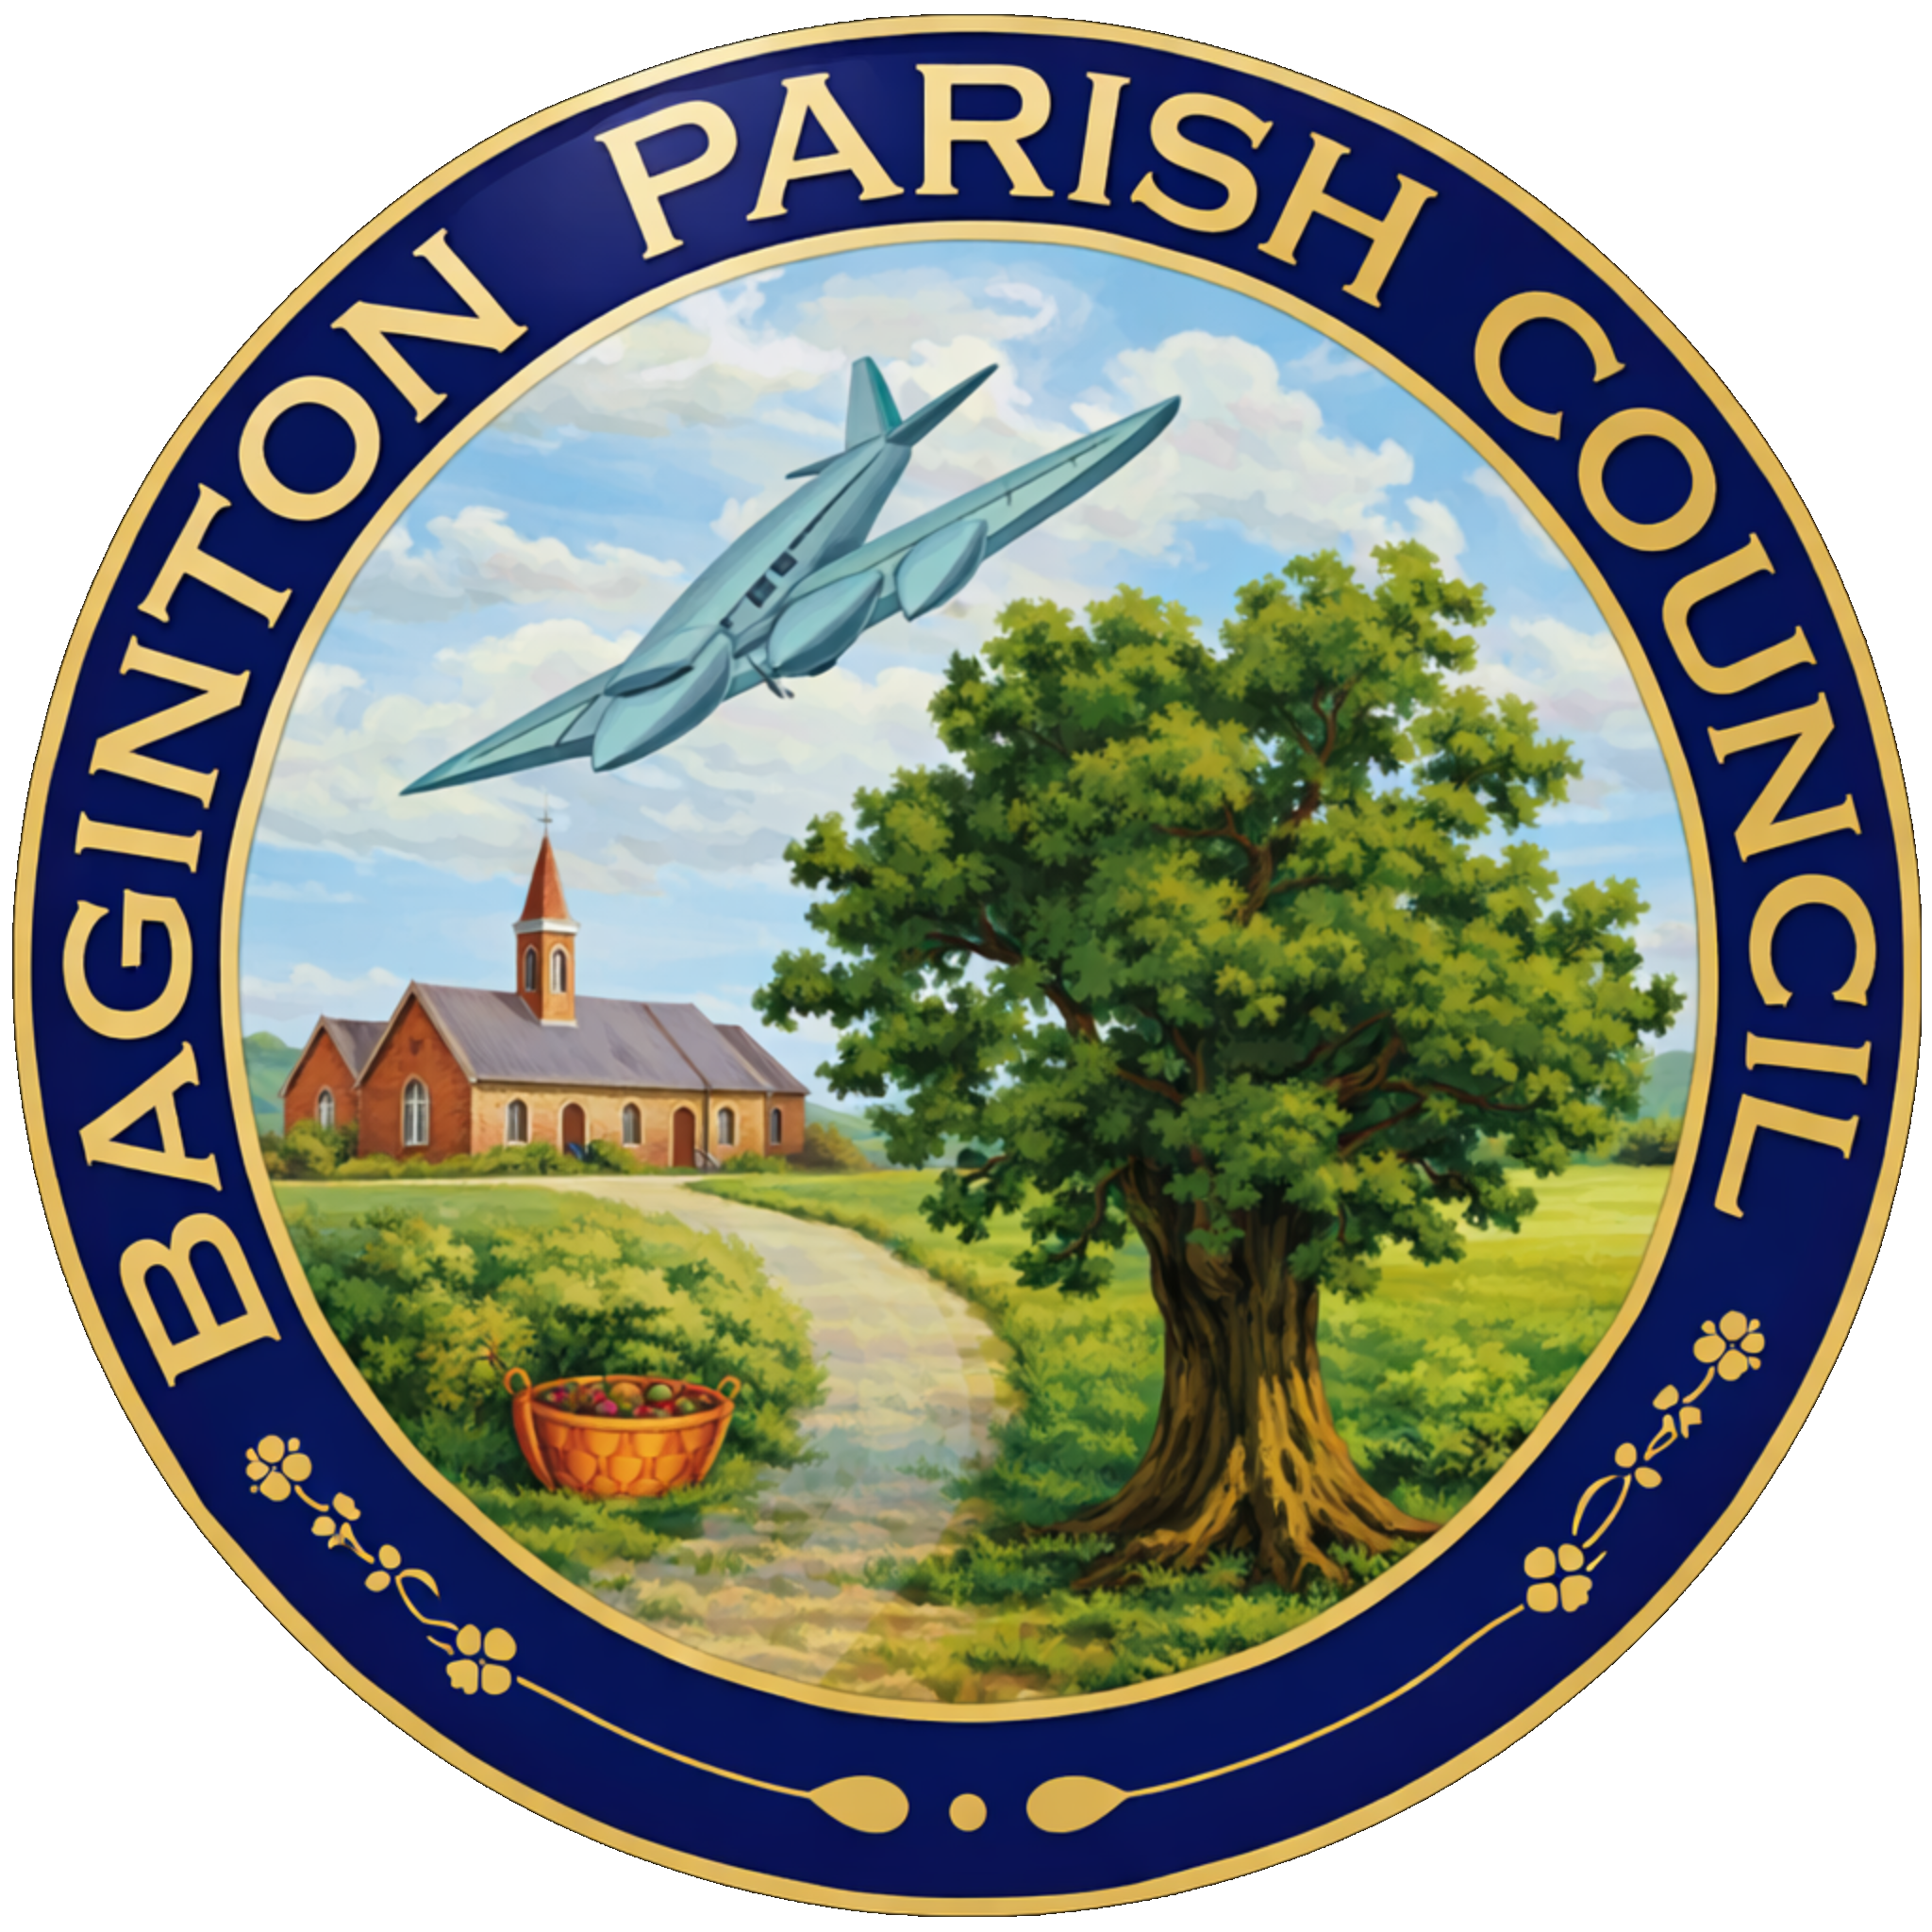
BAGINTON PARISH COUNCIL
59, Meadow Road, Wolston, CV8 3HL
Tel: 07957589626
Email: bagintonpc@gmail.com – clerk@bagintonparish.gov.uk

Minutes of the annual parish council meeting of Baginton Parish Council
Held on 28th May 2026 at 7.30pm at Baginton Village Hall

Cllr Bush, Cllr Newman, Cllr Colville, Cllr Cawley, Cllr Thomas and Cllr Horsfall
In attendance, County Cllr Edwards and Tracie Ball, Clerk and 6 members of the public

- Receive declarations of acceptance from the two councillors co-opted on 6th May 2026.
Cllr Nigel Thomas and Cllr Freya Cawley signed the Declaration of acceptance of office which was witnessed by the Clerk. The Chair welcomed the newly appointed councillors
- Election of Chair 2026-27
Proposal: To appoint Cllr Bush as the new Chair of Baginton Parish Council
Proposed: Cllr Horsfall Seconded: Cllr Colville, Unanimous Resolved
- To receive the Chair’s Declaration of Acceptance of Office
Cllr Bush signed the Declaration of acceptance of office as Chair which was witnessed by the Clerk.
- Election of Vice-Chair 2026-27
Proposal: To appoint Cllr Horsfall as the new Vice-Chair of Baginton Parish Council
Proposed: Cllr Bush Seconded: Cllr Colville, Unanimous Resolved
- To receive the Vice Chair’s Declaration of Acceptance of Office
Cllr Horsfall signed the Declaration of acceptance of office as Vice Chair which was witnessed by the Clerk.
- Re-adoption of Standing Orders and Financial Regulations to be subject to review by August 2026
Standing Orders and Financial Regulations need annual review. Clerk confirmed they remain aligned with current NALC guidance.
Conclusion: Readoption agreed, subject to review by August.
Actions: Clerk to circulate/review policies and regulations over coming weeks/months.
- Re-adoption of Policies and Procedures to be subject to review by August 2026
Policies and procedures need annual review. Clerk confirmed they remain aligned with current NALC guidance.
Conclusion: Readoption agreed, subject to review by August.
Actions: Clerk to circulate/review policies and regulations over coming weeks/months.
- Confirmation of Working Groups and membership
Finance Committee
Cllr Roger Horsfall, Cllr Mike Meakin and Cllr Rob Newman
Events Committee
Cllr Roger Horsfall, Cllr Nigel Thomas and Cllr Rob Newman
Employment
Cllr Walter Bush, Cllr Andrew Parkes and Cllr Nigel Thomas
Open Spaces
Cllr Nigel Thomas, Cllr Walter Bush and Cllr Roger Horsfall
Emergency
Cllr Walter Bush, Cllr Gary Colville and Cllr Roger Horsfall
Firefly
Cllr Walter Bush, Cllr Gary Colville and Cllr Roger Horsfall
- Confirmation of Representation on outside bodies
Coventry Airport
Cllr Roger Horsfall with Cllr Andrew Parkes as named substitute
Village Hall
Cllr Mike Meakin and Cllr Nigel Thomas
Lucy Price ‘Relief in Need’ Charity
Cllr Rob Newman and Cllr Andrew Parkes
Police Liaison
Cllr Walter Bush, Cllr Gary Colville and Cllr Freya Cawley
SEGRO Liaison
Cllr Walter Bush
- Apologies: to receive apologies and approve reasons for absence.
Cllr Meakin, Cllr Parkes, Cllr Newman and Borough Cllr Redford - Accepted
- Declarations of interest
  - To declare any personal interests or prejudicial interests in items on the Agenda and their nature.
None
  - To receive, consider and approve any requests for dispensation relating to Agenda items.
None
- Minutes of previous meeting: To approve the minutes as circulated.
  - 23rd April 2026 and
RESOLVED: that the minutes of the previous meeting held on 23rd April 2026 - having been read and circulated be signed as a correct record. Proposed Cllr Bush Second Cllr Horsfall Unanimous
  - 6th May 2026
RESOLVED: that the minutes of the previous meeting held on 6th May 2026 - having been read and circulated be signed as a correct record. Proposed Cllr Colville Second Cllr Horsfall Unanimous
- Public participation:
A member of the public reported a theft from local business premises. Details of the incident had been provided to Warwickshire Police, including CCTV and vehicle registration information.
The Council noted ongoing concerns regarding retail crime and encouraged continued reporting through the appropriate channels
- Police Matters Update
The Council received an update regarding:
- Ongoing anti-social driving concerns.
- Progress of discussions between Warwickshire County Council, Warwick District Council, Warwickshire Police and other partners.
- Proposed traffic monitoring equipment.
- The importance of residents continuing to report incidents through official police reporting channels.
The Council discussed possible CCTV and data-gathering solutions and noted the complexities associated with data protection and ongoing management responsibilities.
- Baginton Events Committee
  - The Council received an update on forthcoming community events, including:
- The Big Lunch.
- Community film night activities.
- Future events planning.
It was agreed that a separate Events Committee meeting would be arranged to progress future activities.
- Coventry Airport Update
  - Members received an update on:
- The winding up of the Coventry Airport Consultative Committee.
- Future liaison arrangements relating to airport redevelopment proposals.
- Emerging discussions regarding alternative employment uses and development proposals.
The Council agreed that continued engagement with relevant stakeholders remained essential.
- Information items: to consider and discuss items for information and comment if appropriate:
  - County Councillor report
- Community grant funding opportunities.
- Planning enforcement concerns.
- Traffic and construction management issues.
- Ongoing discussions with developers and planning authorities.
Councillors were invited to submit project ideas for potential funding consideration.

  - District Councillors report
    - Update of SWLP – Report has been circulated
Officers from Stratford-on-Avon and Warwick District Councils have introduced the Publication Version of the South Warwickshire Local Plan (2025–2050).
The Plan proposes significant levels of growth across South Warwickshire, including approximately 54,925 new homes, major strategic employment sites, and two proposed new settlements at Long Marston Airfield and Hatton.
The strategy focuses on large-scale, infrastructure-led development in sustainable locations, with significant Green Belt release proposed in some areas, particularly around Warwick District and Kenilworth.
The Plan includes major infrastructure commitments such as new schools, health facilities, transport upgrades, relief roads, and rail improvements.
Councillors should note that current government housing requirements are driving much of this growth and local flexibility on housing numbers is limited. The key opportunity for local influence will therefore be around:
- where development is located,
- what infrastructure is delivered,
- and how local impacts are mitigated.
Formal public consultation is expected to run from 12 June to 27 July 2026, with adoption currently targeted for March 2028.
Cllr Redford will provide a further update on 10th June
  - Local Government Reorganisation in Warwickshire update
No Update – awaiting Government feedback shortly
- Planning Items
  - SEGRO PARK/Gateway South – Update
Cllr Bush – any o/s issues for the next meeting – new building objections
  - Firefly Road Development Working Group – Update
Awaiting Adam Walker WDC – will raise on 10th June update
  - UKBIC – Update
No update
  - WM IZone – Update
Awaiting next meeting
  - Planning decisions received since the last meeting
  - To note applications awaiting WDC decision.
  - New planning applications or matters received since the last meeting
    - W/26/0487 28 Oak Close, Baginton Erection of single-story side extension
had now been resubmitted / reconsidered. Cllrs discussed the current position and noted that earlier concerns remained under review.
    - W/26/0490 Unit 1C, Plot 4020, Siskin Parkway East, Notification for Prior Approval under Schedule 2, Part 14, Class J of the General Permitted Development Order 2015 (as amended) for the installation of other solar PV equipment on a roof of a non-domestic premises
Cllrs indicated that, whilst they were broadly supportive in principle, they wished to maintain the Council’s objection / concern insofar as it related to the wider unresolved highway and Silver Eagle Way / Gate 5 issues.
- Highways Matters
Councillors are advised that the Parish Council is proposing to establish quarterly resident “Highways Surgeries” to allow residents to discuss concerns regarding roads, highways, traffic, and related matters directly with Parish Councillors.
The first proposed surgery will take place on Saturday 4 July 2026 at Baginton British Legion Club between approximately 12:00 noon and 2:00pm.
The event will provide residents with an opportunity to raise concerns, suggest ideas, and discuss local highways matters. Councillors will gather feedback and seek to progress relevant matters with the appropriate authorities, including Warwickshire County Council Highways.
A small display and information area will be set up within the venue.
Councillors are asked to volunteer attendance for the Saturday session.
Publicity will be undertaken via email circulation and a village leaflet drop. Draft publicity material and associated documents will be circulated by the Clerk within the next few days.
- Open Spaces Committee matters to note and update
The Open Spaces Committee met on 20 May 2026 to review ongoing maintenance, wildlife initiatives, and site management across parish open spaces.
Key updates included proposals to work with Warwickshire Wildlife Trust on biodiversity improvements, exploration of a local wildlife recording initiative, and continued maintenance works across Millennium Field, Oak Glade, Lucy Price Playing Field, and other parish sites.
Members noted increasing community use of the open spaces, alongside some incidents of anti-social behaviour and fly-tipping, which have been addressed where possible.
The Committee also reviewed ongoing maintenance priorities, including vegetation management, pond investigations, bench repairs, playground improvements, and future planting schemes.
The next Open Spaces Committee meeting will take place on Wednesday 8 July 2026.
- General Open Spaces Matters to consider/decide matters relating to each as required.
  - Lucy Price Playing Field Maintenance Update
Lucy Price Playing Field – Wet pour Surface Update
Councillors are advised that the rubber mulch surrounding the wet pour wear pads beneath the swings at Lucy Price Playing Field is progressively failing due to ongoing wear and tear.
The proposed solution is to remove the existing wet pour pads and surrounding rubber mulch and replace them with larger wet pour safety pads, increasing the size from approximately 3.5m x 1m to 5m x 2m to provide improved long-term durability.
Three quotations have been obtained:
RPM – approximately £2,800 + VAT
Soft Surfaces – approximately £4,978 + VAT, subject to a number of caveats and potential additional costs
Bernhards Sports Surfaces – approximately £6,635 + VAT
Concerns have been raised regarding:
possible future price increases due to material supply issues,
the extent of caveats within the Soft Surfaces quotation,
affordability of the Bernhards quotation,
and the need to confirm the full scope and quality control arrangements should RPM be considered.
Councillors are requested to consider the quotations received and determine how they wish to proceed.
  - Noticeboards
No update
  - Installation of spare Defibrillator update
RBL Club have agreed just work out next steps – need to check whether existing defibrillator is in working condition.
- Finance - See appendix 1
  - To approve accounts for payment.
RESOLVED: Payment schedule confirmed Proposed Cllr Bush Second Cllr unanimous

  - To confirm payment of Clerk's and Councillors Expenses.
  - To note finance update including bank reconciliation.
  - To note payments received.
  - Any further financial matters to consider
    - Costs for repairs to The Smithy
No Update
Church grants
Fin year | Date | Amount
2022-23 | 4/9/22 | £450
2023-24 | 4/8/23 | £450
2024-25 | 4/10/24 | £450
2025-26 | 13/4/26 | £500
2026-27 | Awaiting grant application
- Matters relating to the parish from Councillors and Clerk – to consider/decide matters relating to each as required.
  - Any other matters arising.
- Future Agenda Items – Councillors are asked to use this opportunity to raise items for future agendas. Councillors are respectfully reminded that this is not an opportunity for debate or decision-making.
- Parish Council Communications (information for sharing) - To receive suggestions for items for the Village website, Parish Council Facebook Page, and Baginton E-news.
  - New Website and Email addresses – update
  - To consider setting up a GDPR Compliant Email newsletter facility for residents – update –
The Clerk updated members on proposals for a GDPR-compliant village email newsletter and communications platform.
Resolved: That a budget of up to £200 be approved to progress the establishment of the service, subject to further details being presented.

- Date of Next Meetings – To confirm Thursday 25th June 2026 at 7.30pm for the for the next regular meeting of the Parish Council.
If an interim meeting is required, an agenda will be sent to Councillors and be put on the website and in the Parish noticeboard three clear days before the meeting is held.
- Confidential matters: to consider the exclusion of the public and press in the public interest for discussions and decisions in relation to either Personnel matters or Legal matters.
Exclusion of Press and Public
In accordance with Paragraph 1 (2) of The Public Bodies (Admission to Meetings) Act 1960, the Parish Council is invited to Resolve that the press and public be excluded from the meeting during consideration of the following agenda items owing to the confidential nature of the business to be transacted and the public interest would not be served in disclosing that information.
- Upcoming meetings
Date | Meeting | Time | Location | Comments
25/06/26 | Baginton Parish Council | 7.30 pm | Baginton Village Hall
18/05/26 | Police ASB | 10.00 am | Virtual
June 26 | WRE Police and Parish Liaison | 7.00 pm | Leek Wootton Police HQ
June 26 | SEGRO Liaison | 4.15 pm | Management Suite
June 26 | WDC: IZone, Gigafactory etc | 3.00 pm | Virtual | Teams
June 26 | NoKSoC | 4.00 pm | Virtual | Teams
10/06/26 | SWLP update – WDC | 2.00pm | Virtual | Teams
08/07/26 | Open spaces | 7.30 pm | Baginton Village Hall
TBC | Baginton Events | 7.30 pm
TBC | Firefly Working Group

Meeting closed at 9:15 pm

Signed …………………………………

Date ……………………………………

appendix 1
Transaction Date | Transaction Description |  | Dr Amount | Cr Amount | Balance | reconciled
Treasurers Account
27/03/2026 | Opening Balance |  |  |  | £5,453.64
31/03/2026 | CPRE | Membership | £45.00 |  | £5,408.64
31/03/2026 | T Ball | March Salary | £469.94 |  | £4,938.70
31/03/2026 | HMRC | March Salary | £142.95 |  | £4,795.75 | TRUE
13/04/2026 | Old Smithy | rent |  | £390.50 | £5,186.25
13/04/2026 | Old Smithy | rent |  | £390.50 | £5,576.75
18/04/2026 | Church | grant | £500.00 |  | £5,076.75
30/04/2026 | T Ball | April Salary | £469.94 |  | £4,606.81
30/04/2026 | HMRC | April Salary | £142.95 |  | £4,463.86 | TRUE
12/05/2026 | ICO |  | £47.00 |  | £4,416.86
28/05/2026 | J Keightley | Defibs | £82.60 |  | £4,334.26
28/05/2026 | T Ball | Salary | £469.94 |  | £3,864.32
28/05/2026 | HMRC | May | £142.94 |  | £3,721.38
28/05/2026 | WALC | Subs | £351.00 |  | £3,370.38 | TRUE
26/02/2026 | Closing balance |  | £2,864.26 | £781.00 | £3,370.38
Bank Balance at | 28/05/2026 | £ 3,370.38 |  | Difference | £0.00
Instant Deposit Account
27/03/2026 | Opening Balance |  |  |  | £28,297.10
29/04/2026 | wdc | Precept |  | £11,250.00 | £39,547.10 | TRUE
 |  |  |  |  | £39,547.10 | TRUE
 |  |  |  |  | £39,547.10 | TRUE
26/03/2026 | Closing balance |  | £0.00 | £0.00 | £39,547.10
Bank Balance at | 28/05/2026 | £ 39,547.10 |  | Difference | £0.00
 |  |  |  | Total Bank | £42,917.48
Payments to be authorised
 | Supplier | Details | inv no | Amount | PAY no | PAID
01/06/2026 | Office Costs and Overheads |  |  | £250.00
01/06/2026 | Litter Pick Honorarium |  |  | £140.00
01/06/2026 | Website Honorarium |  |  | £62.50
01/06/2026 | Gallagher | 25-26 insurance |  | £1,979.52
01/06/2026 | Lakeside | April and March |  | £1,066.50
01/06/2026 | Lakeside | May |  | £355.50
 |  |  |  | £3,498.52

