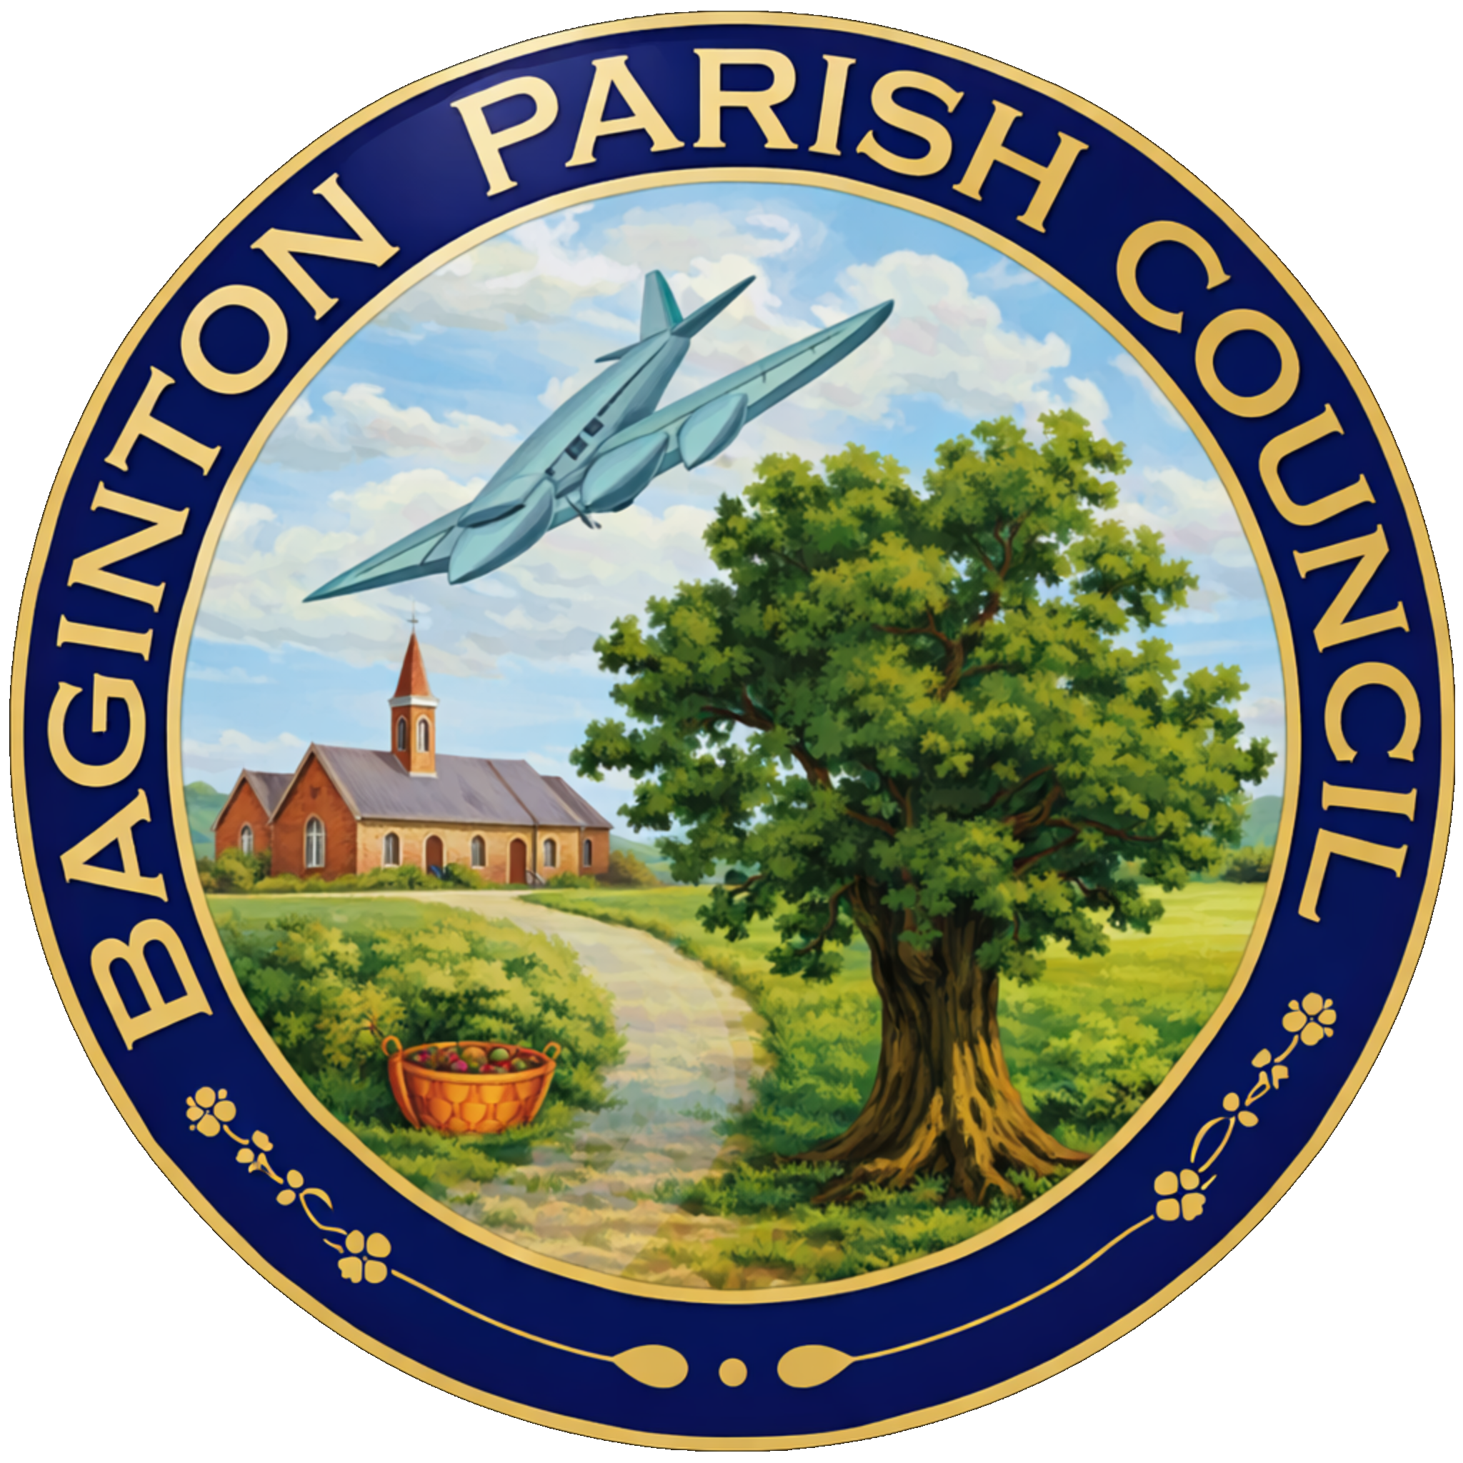
BAGINTON PARISH COUNCIL
59, Meadow Road, Wolston, CV8 3HL
Tel: 07957589626
Email: bagintonpc@gmail.com – clerk@bagintonparish.gov.uk

Minutes of the annual parish council meeting of Baginton Parish Council
Held on 25th June 2026 at 7.30pm at Baginton Village Hall

Cllr Bush, Cllr Parkes, Cllr Newman, Cllr Colville, Cllr Cawley, Cllr Thomas and Cllr Horsfall
In attendance, County Cllr Edwards, District Cllr Redford and Tracie Ball, Clerk and 1 member of the public
- Apologies: to receive apologies and approve reasons for absence.
Apologies were received from Councillor Goodwin
Resolved: That the apologies be accepted.
- Declarations of interest
  - To declare any personal interests or prejudicial interests in items on the Agenda and their nature.
None
  - To receive, consider and approve any requests for dispensation relating to Agenda items.
None
- Minutes of previous meeting: To approve the minutes as circulated.
  - 28th May 2026
RESOLVED: that the minutes of the previous meeting held on 28th May 2026 - having been read and circulated be signed as a correct record. Proposed Cllr Thomas Second Cllr Horsfall Unanimous
- Public participation:
Councillors received an update following the recent Country Park liaison meeting.
It was reported that:
Path improvement works were due to be completed shortly, with sections expected to reopen during early July.
Remaining construction works would continue into 2027.
Discussions had taken place regarding future pedestrian links between Baginton and the Country Park.
Concerns remained regarding safe access for horse riders.
Additional discussions were taking place regarding possible alternative access arrangements.
New litter bins would be installed throughout the park with usage monitored before determining future servicing requirements.
Recycling facilities would be raised with Severn Trent/SEGRO.
Residents had expressed an interest in donating memorial benches.
Proposed names for various areas of the park had been positively received, including:
Rock Farm Way , Oakey Hill, Monk's Meadow, Bluebell Wood, Trinity Bird Sanctuary
A dedicated email address would be established to enable users to report maintenance issues directly.
Concerns were also raised regarding:
Dog control within the Country Park.
The inadequacy of current signage.
The need for larger and clearer information signs, particularly regarding dogs being kept on leads and dog fouling.
The Clerk agreed to continue raising these issues through the liaison meetings.
- Police Matters Update
Councillor Cawley reported following attendance at the recent WRE meeting.
Overall reported crime across the ward had reduced compared with the previous year.
Fly tipping remained an ongoing concern.
Information regarding suspected offenders would continue to be shared with Warwick District Council.
Reports of illegal street racing had reduced although residents were encouraged to continue reporting incidents.
CCTV options for known fly tipping locations continued to be explored.
Community Protection Warnings could be issued where sufficient evidence was available.
Members agreed to continue supporting residents in reporting offences.
- Coventry Airport Update
  - Giga Factory
Members discussed the recent closure of Coventry Airport operations. It was agreed that:
- Although airport operations had ceased, the item should remain on future agendas.
- Continued dialogue with airport management remained important.
- The Council wished to maintain communication regarding future proposals affecting the site.
- Members noted concerns regarding employees affected by the closure and the wider economic impact.
- Information items: to consider and discuss items for information and comment if appropriate:
  - County Councillor report
Cllr Edwards provided input on various items recorded in minutes
  - District Councillors report
Councillors received an update including:
- Availability of Warwick District Council grant funding.
- Community grant opportunities through Warwickshire County Council.
- Funding streams available through landfill and environmental trusts.
- Progress on Local Government Reorganisation.
    - Update of SWLP
update regarding the Regulation 19 consultation.
- Removal of Green Belt land.
- Consultation arrangements.
- Future Examination by the Planning Inspector.
- Concerns regarding the process and timetable.
Cllrs agreed that a detailed response would be considered at the July meeting.
  - Local Government Reorganisation in Warwickshire update
Still awaiting Government discission
- Planning Items
  - SEGRO PARK/Gateway South – Update
Update on Country park received see agenda item – 32
Cllrs were advised that there had been recent industry speculation regarding a potential takeover of SEGRO by logistics developer Prologis. Whilst no formal changes had been confirmed at the time of the meeting, it was considered that the uncertainty surrounding the proposed transaction may be contributing to slower-than-anticipated progress on the Gateway South development.
It was noted that there had been no significant changes on site since the previous meeting. The Parish Council agreed to continue monitoring progress and maintain liaison with SEGRO and other stakeholders, with further updates to be reported as they become available.
  - Firefly Road Development Working Group – Update
Reference was made to Minute 36.1 regarding the potential takeover of SEGRO by Prologis. It was noted that there had been little visible progress on site since the previous meeting, and the Council agreed to continue monitoring the development and maintain dialogue with the developer as further information becomes available.
Action: Clerk to contact Adam Walker, Planning Officer at Warwick District Council, to request an update on the current status of the Firefly development, including any anticipated timescales for future progress, and report back to the Council.
  - UKBIC – Update
No formal updates had been received regarding the UKBIC development since the previous meeting. However, a local resident had reported that a high-pitched noise had once again been experienced during the night. The Council agreed to continue monitoring the situation and requested that any further reports from residents be logged to help identify any recurring pattern.
  - WM IZone – Update
No formal updates had been received
  - Planning decisions received since the last meeting
  - To note applications awaiting WDC decision.
  - New planning applications or matters received since the last meeting
    - W/26/0757 14 Oak Close, Baginton, Erection of wrap-around single storey side and rear extension
Cllrs considered the amended application.
Resolved: To submit a neutral response.
Cllrs also discussed
W/26/0431 2 Coventry Road, Baginton Single and two-storey side and rear extensions, a front extension, the addition of solar panels and a detached outbuilding to the rea
Cllrs considered the application focusing on improvements to the existing property, Installation of a heat pump. Replacement wall construction to improve insulation. Impact upon neighbouring properties.
Resolved: To submit a neutral response

- Highways Matters
Continued HGV movements through the village.
Ongoing evidence gathering by residents.
A WhatsApp reporting group established with SEGRO.
Reports received regarding construction traffic.
Continuing discussions with Warwickshire County Council.
Cllrs agreed that evidence gathering should continue.
- Open Spaces Committee matters to note and update
Routine maintenance works continue
Newly planted trees requiring watering.
Graffiti within the underpass. Reported to WCC
Overgrown vegetation at Roman Way. The Clerk agreed to report the vegetation issues.
Highway visibility issues caused by hedges.
- General Open Spaces Matters to consider/decide matters relating to each as required.
  - Lucy Price Playing Field Maintenance Update
Members considered quotations for replacement wetpour safety surfacing.
Following consideration:
Resolved: To accept the quotation from RPM, subject to confirmation of the specification and final costs.
The annual independent playground inspection would also be arranged.
  - Noticeboards
No updates had been received
  - Installation of spare Defibrillator update
Proposals for installation of a new external defibrillator cabinet.
Discussion included:
Cabinet costs.
Funding through Baginton Events.
Ongoing maintenance arrangements.
Resolved: To proceed with installation, subject to obtaining final quotations and utilising available Baginton Events funding where appropriate.
- Finance
  - To approve accounts for payment.
No invoices requiring approval
  - To confirm payment of Clerk's and Councillors Expenses.
No Councillor or Clerk’s expenses submitted.
  - To note finance update including bank reconciliation.
Current financial position remained unchanged. Noted
  - To note payments received.
None - noted
  - Any further financial matters to consider
    - Costs for repairs to The Smithy
No Change
    - Considered progressing the transfer to Unity Trust Bank
a) The following current councillors be appointed as authorised signatories and mandate holders for the Unity Trust Bank accounts:
Cllr Bush, Cllr Parkes, Cllr Newman, Cllr Colville, Cllr Cawley, Cllr Thomas and Cllr Horsfall
b) The following councillors and officers be granted internet banking access for the Council's Lloyds Bank and HSBC Bank accounts:
Cllr Bush, Cllr Parkes, Cllr Newman, Cllr Colville, Cllr Cawley, Cllr Thomas and Cllr Horsfall
c) Internet banking permissions shall be allocated as follows:
View-only access: Cllr Bush, Cllr Parkes, Cllr Newman, Cllr Colville, Cllr Cawley, Cllr Thomas and Cllr Horsfall
Payment initiation rights: Clerk Tracie Ball
Dual Payment authorisation rights: Cllr Bush, Cllr Parkes, Cllr Newman, Cllr Colville, Cllr Cawley, Cllr Thomas and Cllr Horsfall
Administrative access (where required): Clerk Tracie Ball
Resolved: That all Councillors at the meeting become authorised signatories, with payments requiring dual authorisation.
- Matters relating to the parish from Councillors and Clerk – to consider/decide matters relating to each as required.
  - Any other matters arising.
None
- Future Agenda Items – Councillors are asked to use this opportunity to raise items for future agendas. Councillors are respectfully reminded that this is not an opportunity for debate or decision-making.
- Promotion of forthcoming community events.
- Entrance flower displays for the village.
- Future communications through the Council's WhatsApp group.
- Trinity Guild Rugby Club's offer to work more closely with the Parish Council.
- A proposal to establish Baginton United FC and use the Millennium Field.
- Parish Council Communications (information for sharing) - To receive suggestions for items for the Village website, Parish Council Facebook Page, and Baginton E-news.
  - New Website and Email addresses – update
The new.gov.uk website. Up and running
Email migration. All Cllrs present using gov.uk
Closure of the previous village website.
Resolved:
To request that the existing website displays a notice directing users to the new Parish Council website before it is eventually withdrawn.
  - To consider setting up a GDPR Compliant Email newsletter facility for residents
Members also supported development of a parish e-newsletter through the email and web provider.
- Date of Next Meetings – To confirm Thursday 30th July 2026 at 7.30pm for the for the next regular meeting of the Parish Council.
If an interim meeting is required, an agenda will be sent to Councillors and be put on the website and in the Parish noticeboard three clear days before the meeting is held.
- Confidential matters: to consider the exclusion of the public and press in the public interest for discussions and decisions in relation to either Personnel matters or Legal matters.
- Exclusion of Press and Public
In accordance with Paragraph 1 (2) of The Public Bodies (Admission to Meetings) Act 1960, the Parish Council is invited to Resolve that the press and public be excluded from the meeting during consideration of the following agenda items owing to the confidential nature of the business to be transacted and the public interest would not be served in disclosing that information.
- Baginton Events Committee
  - Update
Members considered future governance arrangements following advice received.
It was agreed:
Baginton Events finances should be incorporated within the Parish Council banking arrangements whilst remaining fully ring-fenced.
Separate financial records would continue to be maintained.
Updated Terms of Reference would be prepared.
Future VAT implications relating to ticketed events would be clarified.
Existing event management arrangements would continue pending further advice.
Members also considered outstanding correspondence relating to Mr Bull. - The Clerk was authorised to prepare an appropriate response following the advice received.
  - To review and approve updated Terms of Reference for Baginton Events Committee
Clerk to prepared updated TOR
- Council Communications
Item not discussed
- Upcoming meetings
Date | Meeting | Time | Location | Comments
25/06/26 | Baginton Parish Council | 7.30 pm | Baginton Village Hall
August 26 | Police ASB | 10.00 am | Virtual
22/06/26 | WRE Police and Parish Liaison | 7.00 pm | Leek Wootton Police HQ
18/06/26 | SEGRO Liaison | 4.15 pm | Management Suite
12/06/26 | WDC: IZone, Gigafactory etc | 3.00 pm | Virtual | Teams
June 26 | NoKSoC | 4.00 pm | Virtual | Teams
July 26 | Open spaces | 7.30 pm | Baginton Village Hall
08/07/26 | Baginton Events | 7.30 pm
TBC | Firefly Working Group

Closed 9:30pm

