BAGINTON PARISH COUNCIL
59, Meadow Road, Wolston, CV8 3HL
Tel: 07957589626
Email: bagintonpc@gmail.com – clerk@bagintonparish.gov.uk

TO: All Councillors, Baginton Parish Council
Dear Councillor
You are hereby summoned to attend a meeting of Baginton Parish Council at Baginton Village Hall on Thursday 30th July 2026 at 7.30pm. Please forward any apologies for absence to me or the Chair.
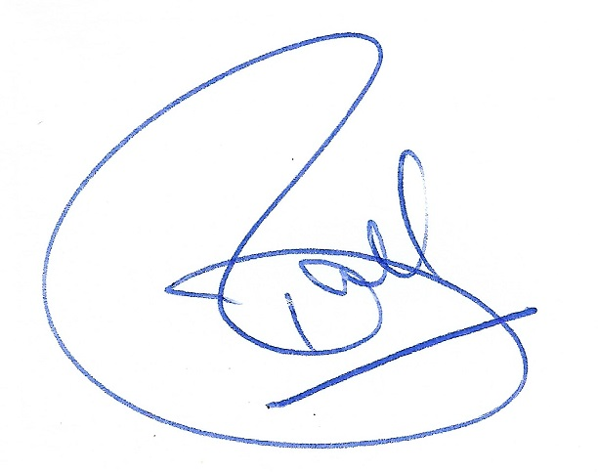
Tracie Ball
Clerk and RFO
22nd July 2026

Members of the public and press are welcome to attend.
A G E N D A
- Apologies: to receive apologies and approve reasons for absence.
- Resignation of Councillor Meakin
To formally acknowledge the resignation of Councillor Mike Meakin from Baginton Parish Council, received on 21stJuly 2026 and to record the Council's thanks for his dedicated service to the Parish and the community.
- Declarations of interest
  - To declare any personal interests or prejudicial interests in items on the Agenda and their nature.
  - To receive, consider and approve any requests for dispensation relating to Agenda items.
- Minutes of previous meeting: To approve the minutes as circulated.
  - 25th June 2026
- Public participation: to adjourn to allow public participation for 15 minutes. Residents are invited to give their views and question the Parish Council on issues on this Agenda or raise issues for future consideration at the discretion of the Chair. If members of the public wish to raise issues which are not on the agenda, they should notify the Clerk, 5 working days prior to the meeting. Members of the public may not take part in the Parish Council meeting itself. Maximum 5 mins per issue.
- Police Matters Update
- Coventry Airport Update
  - Giga Factory
- Information items: to consider and discuss items for information and comment if appropriate:
  - County Councillor report
  - District Councillors report
  - Update of SWLP
  - Local Government Reorganisation in Warwickshire update
- Planning Items
  - SEGRO PARK/Gateway South – Update
  - Firefly Road Development Working Group – Update
  - UKBIC – Update
  - WM IZone – Update –
  - Planning decisions received since the last meeting
  - To note applications awaiting WDC decision.
  - New planning applications or matters received since the last meeting
    - W/26/0937/AG 13 The Smallholdings, Stoneleigh Road, Baginton
- Highways Matters
- Baginton Events Committee
  - Update
- Open Spaces Committee matters to note and update
- General Open Spaces Matters to consider/decide matters relating to each as required.
  - Lucy Price Playing Field Maintenance Update – where is funding coming from – Bag events
  - Noticeboards
  - Installation of spare Defibrillator update – quotes for new one
- Finance
  - To approve accounts for payment.
  - To approve and confirm payment of Clerk's and Councillors Expenses.
  - To note finance update including bank reconciliation.
  - To note payments received.
  - Any further financial matters to consider
    - Costs for repairs to The Smithy
  - Banking Arrangements – Transfer to Unity Trust Bank
    - To consider the Clerk's report and resolve to:
a) Approve the transfer of the Council's banking arrangements from HSBC to Unity Trust Bank.
b) Authorise the opening of the following Unity Trust Bank current accounts:
- Baginton Parish Council (General Account)
- Baginton Events (Ring-fenced Account)
c) Authorise the Clerk to complete all necessary documentation and administrative actions required to facilitate the transfer of banking services and the opening of the new accounts.
  - Unity Trust Bank – Bank Signatory Mandate
    - To consider and resolve:
a) The authorised signatories for the Unity Trust Bank accounts.
b) The level of authorisation required for payments and banking transactions, in accordance with the Council's Financial Regulations.
c) To authorise the Clerk to submit the approved bank mandate and any associated documentation to Unity Trust Bank to activate the accounts.
- Letter of Concern Received
To receive and consider the letter of concern dated 10 April 2026 received from Mr Jeffrey C. Bull regarding governance and operational matters relating to Baginton Parish Council and Baginton Events, to determine the Council's position on the matters raised, and to agree the Council's formal response to the complainant.
- Matters relating to the parish from Councillors and Clerk – to consider/decide matters relating to each as required.
  - Any other matters arising.
- Future Agenda Items – Councillors are asked to use this opportunity to raise items for future agendas. Councillors are respectfully reminded that this is not an opportunity for debate or decision-making.
- Parish Council Communications (information for sharing) - To receive suggestions for items for the Village website, Parish Council Facebook Page, and Baginton E-news.
  - GDPR Compliant Email newsletter facility for residents - update
- Date of Next Meetings – To confirm Thursday 24th September 2026 at 7.30pm for the for the next regular meeting of the Parish Council.
If an interim meeting is required, an agenda will be sent to Councillors and be put on the website and in the Parish noticeboard three clear days before the meeting is held.
Upcoming meetings
Date | Meeting | Time | Location | Comments
24/09/26 | Baginton Parish Council | 7.30 pm | Baginton Village Hall
August 26 | Police ASB | 10.00 am | Virtual
Sept 26 | WRE Police and Parish Liaison | 7.00 pm | Leek Wootton Police HQ
Sept 26 | SEGRO Liaison | 4.15 pm | Management Suite
Sept 26 | WDC: IZone, Gigafactory etc | 3.00 pm | Virtual | Teams
Sept 26 | NoKSoC | 4.00 pm | Virtual | Teams
TBC | Open spaces | 7.30 pm | Baginton Village Hall
TBC | Baginton Events | 7.30 pm
TBC | Firefly Working Group

