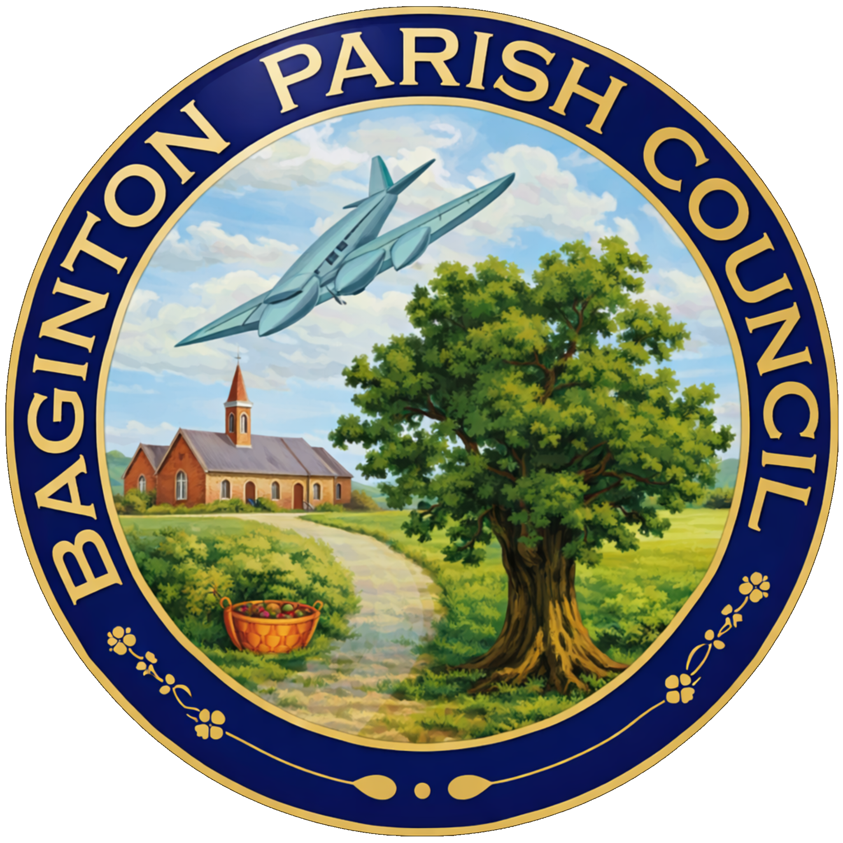
BAGINTON PARISH COUNCIL
59, Meadow Road, Wolston, CV8 3HL
Tel: 07957589626
Email: bagintonpc@gmail.com – clerk@bagintonparish.gov.uk

TO: All Councillors, Baginton Parish Council
Dear Councillor
You are hereby summoned to attend a meeting of Baginton Parish Council at Baginton Village Hall on Thursday 24th September 2026 at 7.30pm. Please forward any apologies for absence to me or the Chair.
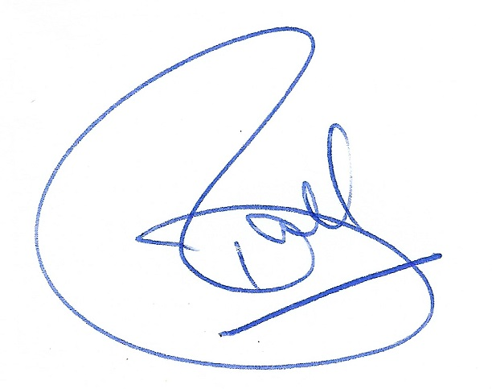
Tracie Ball
Clerk and RFO
17th September 2026

Members of the public and press are welcome to attend.
A G E N D A
- Apologies: to receive apologies and approve reasons for absence.
- Resignation of Councillors Goodwin and Crawley
  - To formally acknowledge the resignations of Councillor Goodwin and Councillor Crawley and to record the Council’s thanks for their service and contribution to Baginton Parish Council and the local community.
- Co-option of Parish Councillors – Three Vacancies
  - Applications for Co-option
To receive and consider applications from eligible candidates for co-option to the three current vacancies on Baginton Parish Council and to provide candidates with an opportunity to address the Council.
  - Co-option of Councillors
To consider the applications received and to vote to co-opt up to three eligible candidates to fill the current vacancies on Baginton Parish Council.
  - Declaration of Acceptance of Office
For each successful candidate present to make and sign their Declaration of Acceptance of Office and thereby take office as a Member of Baginton Parish Council. Section 83 of the Local Government Act 1972 requires a parish councillor to make the prescribed declaration before or at the first meeting following their election/co-option, unless the Council permits it to be made at a later meeting.
  - Code of Conduct and Register of Interests
To confirm that each newly co-opted Councillor will be provided with the Council's Code of Conduct and the appropriate Register of Interests documentation and advised of the requirement to notify the Monitoring Officer of their relevant interests within 28 days of becoming a Councillor.
  - Notification of Co-options
To authorise the Clerk to notify Warwick District Council/Electoral Services and the Monitoring Officer of the successful co-options and complete all associated administrative requirements.
- Declarations of interest
  - To declare any personal interests or prejudicial interests in items on the Agenda and their nature.
  - To receive, consider and approve any requests for dispensation relating to Agenda items.
- Minutes of previous meeting: To approve the minutes as circulated.
  - 30th July 2026
- Public participation: to adjourn to allow public participation for 15 minutes. Residents are invited to give their views and question the Parish Council on issues on this Agenda or raise issues for future consideration at the discretion of the Chair. If members of the public wish to raise issues which are not on the agenda, they should notify the Clerk, 5 working days prior to the meeting. Members of the public may not take part in the Parish Council meeting itself. Maximum 5 mins per issue.
- Police Matters Update
- Coventry Airport Update
  - Giga Factory
- Information items: to consider and discuss items for information and comment if appropriate:
  - County Councillor report
  - District Councillors report
  - Update of SWLP
  - Local Government Reorganisation in Warwickshire update
- Planning Items
  - SEGRO PARK/Gateway South – Update
  - Firefly Road Development Working Group – Update
  - UKBIC – Update
  - WM IZone – Update
  - Planning decisions received since the last meeting
  - To note applications awaiting WDC decision.
  - New planning applications or matters received since the last meeting
    - W/26/0937/AG 13 The Smallholdings, Stoneleigh Road, Baginton
- Highways Matters
- Baginton Events Committee
  - Update
- Open Spaces Committee matters to note and update –
  - Parish Trees – Safety Inspection/Tree Survey
  - Warwickshire Wildlife Trust – Trees, Wildflowers and Community Planting Project
  - Village Entrance Planters
- General Open Spaces Matters to consider/decide matters relating to each as required.
  - Lucy Price Playing Field Maintenance Update – where is funding coming from – Bag events
  - Noticeboards
  - Installation of spare Defibrillator update – quotes for new one
- Finance
  - To approve accounts for payment.
  - To approve and confirm payment of Clerk's and Councillors Expenses.
  - To note finance update including bank reconciliation.
  - To note payments received.
  - To receive an update regarding the condition of The Smithy and any repairs or maintenance required; to consider estimated costs, available funding and potential grant opportunities; and to agree any further action.
  - Unity Trust Bank – Banking Arrangements Update
To receive an update from the Clerk/RFO on the establishment of the Council’s Unity Trust Bank accounts, including the General Account and Baginton Events ring-fenced account; to consider any outstanding mandate, signatory or authorisation requirements; and to approve any further actions necessary to complete the transfer of banking arrangements.
  - St John’s Church – Grant Application
To receive and consider the grant application submitted by St John’s Church, including the purpose of the funding requested, and to determine whether a grant should be awarded and, if so, the amount and any conditions attached.
- Matters relating to the parish from Councillors and Clerk – to consider/decide matters relating to each as required.
  - Any other matters arising.
- Future Agenda Items – Councillors are asked to use this opportunity to raise items for future agendas. Councillors are respectfully reminded that this is not an opportunity for debate or decision-making.
- Parish Council Communications (information for sharing) - To receive suggestions for items for the Village website, Parish Council Facebook Page, and Baginton E-news.
  - GDPR Compliant Email newsletter facility for residents - update
- Date of Next Meetings – To confirm Thursday 29th October 2026 at 7.30pm for the for the next regular meeting of the Parish Council.
If an interim meeting is required, an agenda will be sent to Councillors and be put on the website and in the Parish noticeboard three clear days before the meeting is held.

Upcoming meetings
Date | Meeting | Time | Location | Comments
29/10/26 | Baginton Parish Council | 7.30 pm | Baginton Village Hall
September 26 | Police ASB | 10.00 am | Virtual
28 Sept 26 | WRE Police and Parish Liaison | 7.00 pm | Leek Wootton Police HQ
16 Sept 26 | SEGRO Liaison | 4.15 pm | Management Suite
Sept 26 | WDC: IZone, Gigafactory etc | 3.00 pm | Virtual | Teams
Sept 26 | NoKSoC | 4.00 pm | Virtual | Teams
14/10/26 | Open spaces | 7.30 pm | Baginton Village Hall
TBC | Baginton Events | 7.30 pm
TBC | Firefly Working Group

